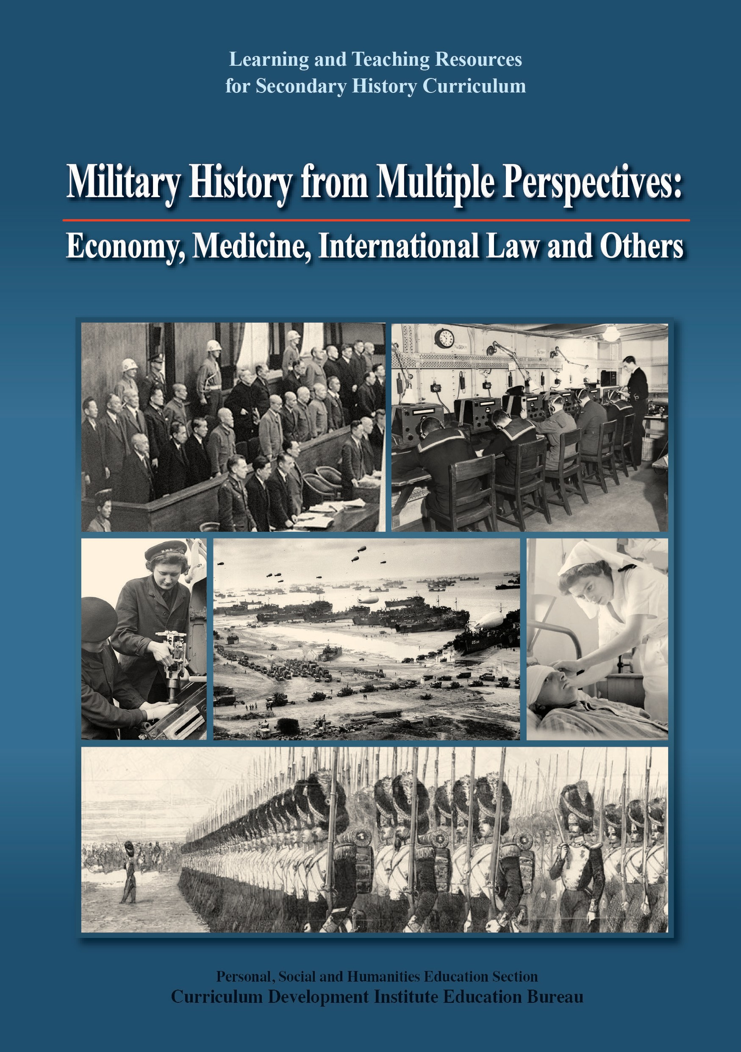

2
About the cover page 3

About the cover page

Position | Description
Top (Left) | War criminals in the dock of the International Military Tribunal for the Far East (two rows at the back). (National Library of China . National Digital Library of China)
Top (Right) | The Royal Navy soldiers using communication tools during the Second World War.  (Beadell, S J (Lt), Royal Navy official photographer, Public domain, via Wikimedia Commons)
Middle (Left) | The Women’s Royal Naval Service during the Second World War.  (Royal Navy official photographer, Tomlin, H W (Lt), Public domain, via Wikimedia Commons)
Middle (Middle) | Photograph of the French Invasion Beach, 1944 (ID 12003973, National Archives Catalog)
Middle (Right) | A nurse takes care of an injured Royal Air Force airman with head injury during the Second World War. (© IWM CBM 1993)
Bottom | Review of the Imperial Guard at the Champ de Mars. (« Source gallica.bnf.fr / Bibliothèque nationale de France »)

Preface

The learning and teaching resources for Secondary History Curriculum entitled Military History from Multiple Perspectives: Economy, Medicine, International Law and Others is published by the Personal, Social and Humanities Education Section of Curriculum Development Institute, Education Bureau (EDB). It aims to support teachers in implementing the learning and teaching of the revised History Curriculum (S1-3), and help them understand the features and requirements of the revised curriculum. Teachers of Senior Secondary History can also refer to these resources while teaching relevant topics.

In order to enhance students’ interest in studying history, military history, one of the new learning elements, has been added to the revised History curriculum (S1-3) to provide students with different perspectives in understanding the impact of wars on the development of history, such as how military innovations of the two world wars were used in our daily lives. Not only can the study of military history cater for students’ different learning needs and interests, and broaden their historical and global perspectives, it also enables them to understand that wars are man-made tragedies that brought various degrees of harm and destruction to almost everyone concerned, so as to cultivate positive values and attitudes such as cherishing peace, caring and perseverance.

The contents of the resources comprise two parts. The first part consists of the lecture notes of the Knowledge-Enrichment Lecture Series relevant to military history, which was conducted for History teachers earlier by Dr. Kwong Chi-man, Associate Professor of Department of History of Hong Kong Baptist University at the invitation of the EDB. This part covers five thematic chapters, each focuses on one theme: “War and Economy”, “War and International Law”, “War and Medicine”, “War and Society”, and “War and Technological Innovations”. A suggested reading list is attached to each chapter for teachers’ reference. The second part consists of two examples of teaching plan on the theme of military history, which includes elements of e-Learning, enquiry learning and field study, etc. Teachers can make use of these examples flexibly in accordance with school context and students’ ability and interest.
Teachers are advised to refer to and make good use of various learning strategies in the History Curriculum Guide (S1-3) so as to complement the resources. In addition, two sets of presentation materials are also designed to demonstrate how the resources can be used for daily learning and teaching effectively.

The learning and teaching resources and the related presentation materials have been uploaded to the website of the EDB for teachers’ reference:
https://www.edb.gov.hk/en/curriculum-development/kla/pshe/references- and-resources/history/military_history.html

No part of the resources may be reproduced in any form for commercial purposes. We are grateful to the organisations for permission to quote their publications in this book. Every effort has been made to trace copyright ownership but in the event of accidental infringement, copyright owners are invited to contact us so that we can come to a suitable arrangement.

If you have any comments and suggestions on the learning and teaching resources, please send to:

Personal, Social and Humanities Education Section Curriculum Development Institute
Education Bureau
Room 1319, 13/F, Wu Chung House, 213 Queen’s Road East Wanchai, Hong Kong or
Fax: 2573 5299 / 2575 4318
E-mail: infopshe@edb.gov.hk

4 Preface Preface 5

Abstract of Curriculum Guide
The resources entitled Military History from Multiple Perspectives: Economy, Medicine, International Law and Others is produced to support the implementation of the History Curriculum Guide (S1-3) (The Curriculum Guide can be downloaded from the EDB website: https://www.edb.gov.hk/attachment/en/curriculum- development/kla/pshe/Hist_Curr_Guide_S1-3_Eng_final_10072019.pdf). Before using the learning and teaching resources, teachers should refer to the above curriculum guide to understand the rationale, aims and learning objectives of the revised curriculum, as well as the learning focus of each topic.

Curriculum Aims
The aims of Secondary 1-3 History curriculum are:
- to enhance and develop students’ interest in studying history;
- to help students understand the present in the context of the past;
- to enrich students’ knowledge of their own community and culture, as well as other major cultures of the world;
- to develop students’ historical skills and generic skills for further studies and life situations;
- to nurture students to become citizens who have global perspectives, knowledge and sense of responsibility.

Learning Objectives
After completion of the junior secondary History curriculum, students should be able to:
- Knowledge and Understanding
  - understand and comprehend from a variety of perspectives (political, economic, technological and scientific, social, religious, aesthetic, etc.), the main characteristics of world civilisations in different periods;
  - understand and comprehend the main characteristics of the development of Hong Kong and to relate them to the national and world development;
  - comprehend basic historical concepts and terms;
  - understand the relationship between cause and consequence of historical events;
  - comprehend change and continuity in major historical issues and developments;
  - understand that the past may be interpreted in different ways;

- Skills
  - use historical terminology in an appropriate way;
  - present historical events accurately in chronological order;
  - describe characteristics of historical maps, models, diagrams, charts, pictures, tables and cartoons;
  - make deductions and inferences from historical sources;
  - identify different interpretations of major historical events and personalities;
  - distinguish the differences between historical facts and opinions;
  - comprehend the implication of sources, question and explore the accuracy and reliability, and then construct fair and impartial personal views;
  - make an imaginative reconstruction of past events;
  - select, organise and deploy sources, and express in a well-structured way;

- Attitudes and Values
  - develop an interest in the past and an appreciation of human achievements and aspirations;
  - relate the study of history to contemporary life;
  - understand views, beliefs and values of different societies at different times so as to develop positive values and attitudes;
  - be willing to take up the responsibility of preserving antiquities and monuments, conserving cultural heritage and promoting history and culture.

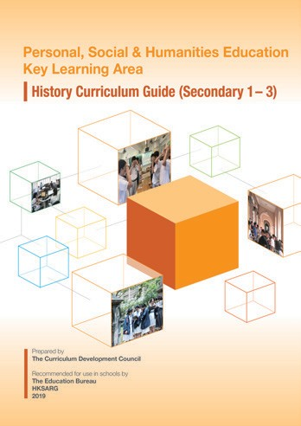 6 Abstract Abstract 7

Suggestion for use
The learning and teaching resources entitled Military History from Multiple Perspectives: Economy, Medicine, International Law and Others is published by the Personal, Social and Humanities Education Section of the Curriculum Development Institute, Education Bureau (EDB). It aims to support teachers in implementing the learning and teaching of the revised History Curriculum (S1-3) so as to help them understand the features and requirements of the revised curriculum. In order to help teachers effectively use the resources in enhancing learning and teaching effectiveness, we have designed the following two presentation materials to demonstrate how the resources can be used for daily learning and teaching effectively.
Presentation materials | Content
PowerPoint 1  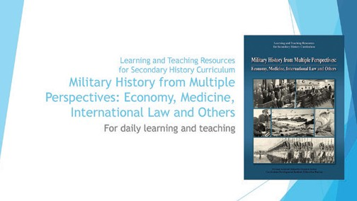 | - Introduce the content of the resources  - Illustrate how to use the resources to construct historical knowledge, train historical skills and cultivate positive values and attitudes, etc.
PowerPoint 2  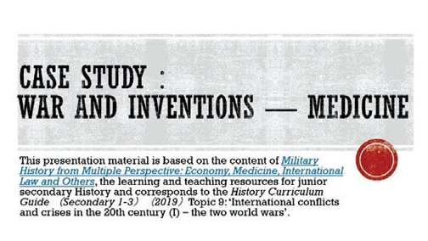 | - Design according to the learning points of “Case study: Wars and inventions” in “Topic 9: International conflicts and crises in the 20th century (I) – the two world wars” of the History Curriculum Guide (Secondary 1-3) (2019)  - Use the contents of the resources and the professional knowledge of teachers to help students understand that wars are man-made tragedies; and realise that although wars have led to medical inventions, they have brought varying degrees of harm to almost everyone concerned. This helps cultivate in students positive values and attitudes such as cherishing peace, and upholding caring for others and perseverance.

Contents
About the cover page 3
Preface 4
Abstract of Curriculum Guide 6
Suggestion for use 8
Contents 9
Part I: Lecture Notes
Foreword 13
Chapter 1: War and Economy 16
Chapter 2: War and International Law 32
Chapter 3: War and Medicine 46
Chapter 4: War and Society 62
Chapter 5: War and Technological Innovations 76
Part II: Examples of Teaching Plans

Teaching plan 1:
Wars and Inventions (Topic 9: International conflicts and crises in the
20th century (I) – the two world wars) 92
Teaching plan 2:
Field study of the Wong Nai Chung Gap at Wan Chai District (Topic 12:
The growth and transformation of Hong Kong in the 20th century) 110
The learning and teaching resources and the related PowerPoints have been uploaded
to the website of the EDB for reference. Teachers can visit the relevant website by following the link below or scanning the QR code.
Website: https://www.edb.gov.hk/en/curriculum- QR Code: development/kla/pshe/references-and-resources/ history/military_history.html
8 Suggestion for use
Contents 9

MILITARY HISTORY FROM MULTIPLE PERSPECTIVES:
ECONOMY, MEDICINE, INTERNATIONAL LAW AND OTHERS

Dr. KWONG, Chi Man
Associate Professor, Department of History, Hong Kong Baptist University

Part I

Lecture Notes

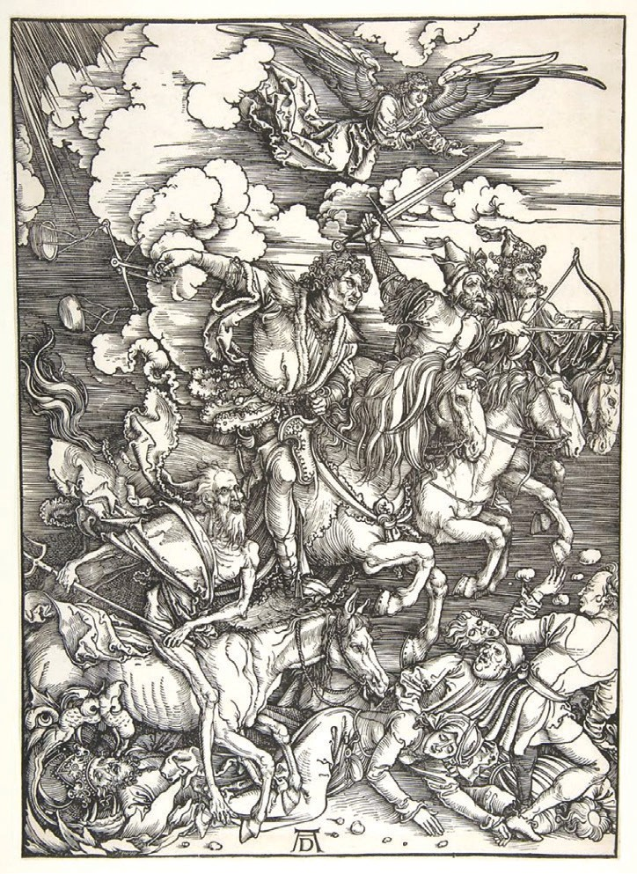Foreword

The Four Horsemen, from The Apocalypse, 1498 (Albrecht Dürer)

“Albrecht Dürer’s The Four Horsemen of the Apocalypse in 1498 was one of the most famous woodcuts by the German artist. He made it as part of a series to illustrate the book of Revelation in the Bible. It shows the coming of, from left to right, Death, Famine, War and Pestilence. In his depiction, as is often the case in war, the four are intimately linked and trample the helpless civilians without
mercy.”
From War: How Conflict Shaped Us by Margaret Macmillan, figure 3
One cannot ignore the existence of wars in history. War brings not only political changes but also changes in values, gender relations, science, technology, economy, and society. However, when one studies wars in history, one should always remember that they were man-made tragedies that brought destruction and suffering to almost everyone concerned. When we discuss war, we ought not to focus only on technical details and overlook the larger contexts of each conflict.
12 CFohraepwteorrd1: War and Economy Foreword 13

Chapter 1
War and Economy

Chapter 1: War and Economy

Introduction
War and economy were inseparable. Without money, armies cannot be organized and sustained, and weapons cannot be procured. Before the early modern period, there were two ways for kings and emperors to pay for their wars, namely collecting tax or plundering. The former was common in agricultural societies whilst the nomads preferred the latter. However, as the scale of war escalated in early modern Europe, credit agencies specialized for war funds emerged; the availability of loans, in turn, sustained large armies and navies. When it came to the 20th century, the mode of war transformed from “limited war”i to “total war,” making economic mobilization a vital factor of victory or defeat. In this passage, we will briefly go through relationship between war and economy in history, focusing on the modern times.

War, Centralized State, and the Financial Revolution
In the Medieval period, monarchs kept small standing armies, and larger forces were raised from the nobility when war broke out. Hence, the financial burden of medieval rulers was limited; on the other hand, they could hardly afford a prolonged war. At the beginning of the early modern period, European monarchs did not have a sophisticated understanding of war economy. To them, the problem was mainly about raising sufficient funds for hiring troops and procuring food and equipment. However, as gunpowder weapons popularized in the late 15th century, the mode of war changed, and the duration of conflicts lengthened. If a ruler wanted to survive and thrive, large sums of money had to be spent on keeping a standing army, forging guns, and building bastions. Correspondingly, monarchs tightened the control over their territories and subjects, mainly through creating local institutions that helped generate revenue, and gradually building centralized states. This political transformation, propelled partly by gunpowder, was called “Military Revolution” (or Revolution of Military Affairs).

Nevertheless, tax revenues were hardly sufficient for the usually huge war expenses. Thus, monarchs would borrow money from bankers in Europe. By the mid-17th century, Amsterdam of the Netherlands had become the European financial hub, where bankers lent money to their clients regardless of their religion and
ethnicity. Later in the 17th century, Britain founded her national bank and the stock market and issued national bonds, essentially borrowing money from its people. Gradually, other European countries followed suit and were able to maintain larger armed forces.

The existence of banks, however, were not enough for nations to raise enough war funds consistently. The key was to have “credit”. Credit rating determined not only the amount of loan that a nation could borrow but also the interest rate, which was vital to the nation’s post-war economy. The examples of Britain and France during the late 18th century was a case in point. At that time, although Britain had just lost the American War of Independence and her national debt was £200 million, her interest rate was just 3%. France, on the other hand, had to accept a floating interest rate doubled that of Britain’s despite borrowing much less, since she had a lower credit rating. When it came to the late 1780s, partly due to her poor financial management, France’s national debt level matched up with Britain’s, but she was paying double for interest.

▲ Figure 1.1: A lithograph entitled “The Destruction of Tea at Boston Harbor” portrayed a historical incident occurred in 1773, which was related to the taxation system introduced by the British government over the Thirteen Colonies. It is also known as one of the factors that led to the American Revolution. (Nathaniel Currier, Public domain, via Wikimedia Commons)

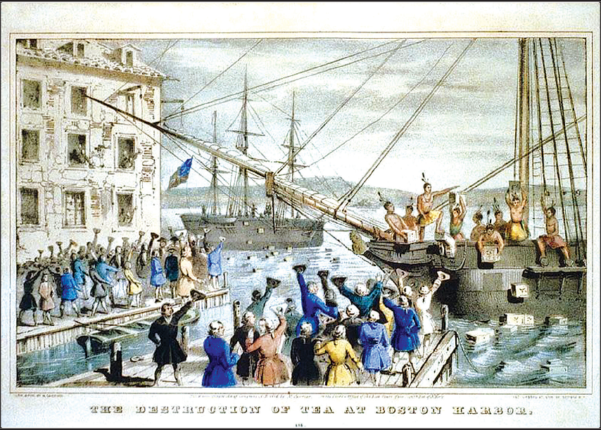
16 Chapter 1: War and Economy Chapter 1: War and Economy 17

Napoleonic Era: Trade and War
To maintain and improve credit rating, repaying debts on time is necessary but not sufficient, the borrower should demonstrate his/her repayment ability. Britain’s ability to borrow was mainly built on her naval superiority; that is to say, as long as she controlled the oceans, she could maintain her maritime trade. However, maritime trade was the strength as well as the weakness for Britain. At the turn of the 19th century, France dominated continental Europe while Britain commanded the seas, neither of them could defeat the other. Napoleon realized that Britain’s maritime trade must be disrupted before Britain could be defeated. Thus, he attempted to build the Continental Systemii (1806-1814) in 1806, forbidding all continental countries from trading with Britain. Britain faced an imminent economic crisis. Her export diminished, goods unsold, workers unemployed, and national debt increased; ceasefire was seemingly the only option. Fortunately for Britain, Spain and Russia successively broke up with France and resumed their trade with Britain; in the meantime, British goods were brought into the continent by smugglers. Britain was also able to expand its trade with South America.

▲ Figure 1.3: A British cartoon published during the Napoleonic Wars, depicting the economic blockade against France. For more information about the contents of the cartoon, please refer to: https:// digitalcollections.lib.washington.edu/digital/collection/napoleon/id/159/ . (University of Washington Libraries, Special Collections, [NAP011])

The French economy was also unavoidably affected by the Continental System. In the short term, thanks to the absence of British goods, the French textile industry thrived; moreover, the expansion of the First French Empire broadened her market. However, the French textile industry could not import the latest equipment from the greatest industrial power of the time — Britain, while the coastal blockade launched by the Royal Navy circumscribed the Atlantic trade of France. To force Russia to stay in the Continental System, Napoleon launched the disastrous invasion of Russia in 1812. These factors partly explained the failure of the Continental System. In the end, the Continental System failed despite its initial success.

▲ Figure 1.2: Continental System introduced by Napoleon in 1806.
The defeat of Napoleon in 1815 confirmed Britain’s economic edge. Since international trade was the foundation of her power, Britain promoted international trade in different parts of the world, sometimes even by force and led to unforeseen consequences. On the other hand, the prolonged war prompted European nations to look for possibilities of peaceful coexistence, leading to the Concert of Europe. This led to a level of international cooperation unseen before the Napoleonic Wars.

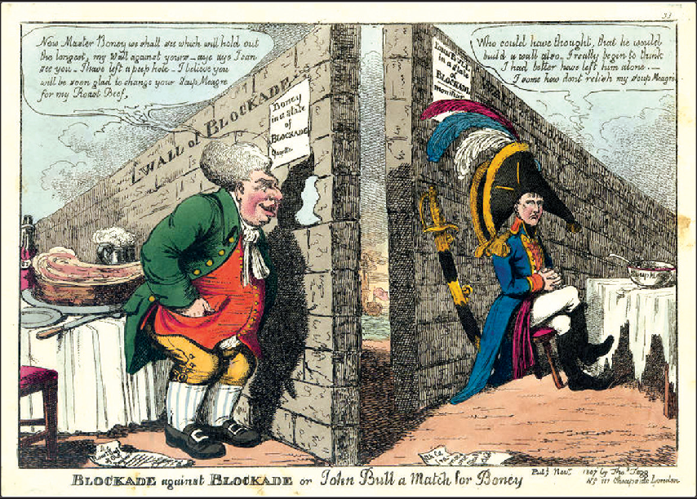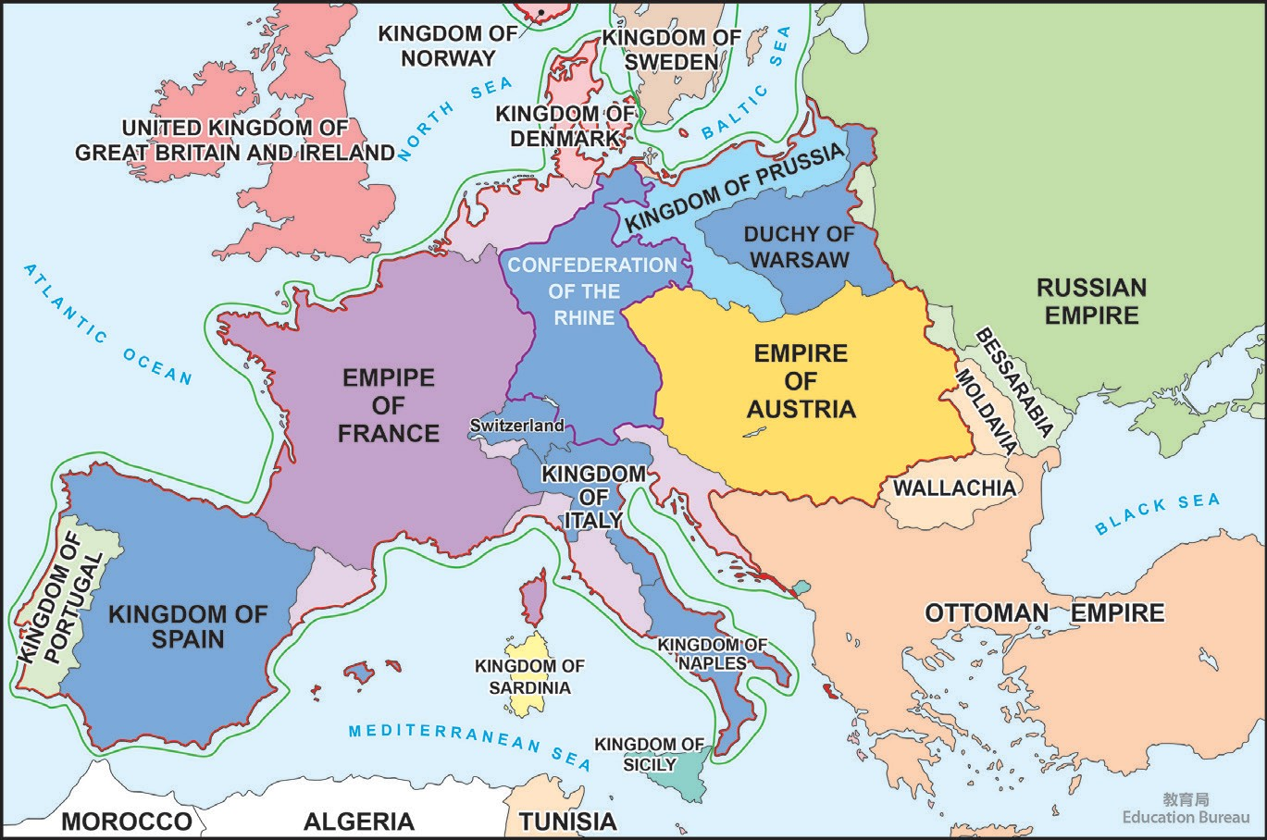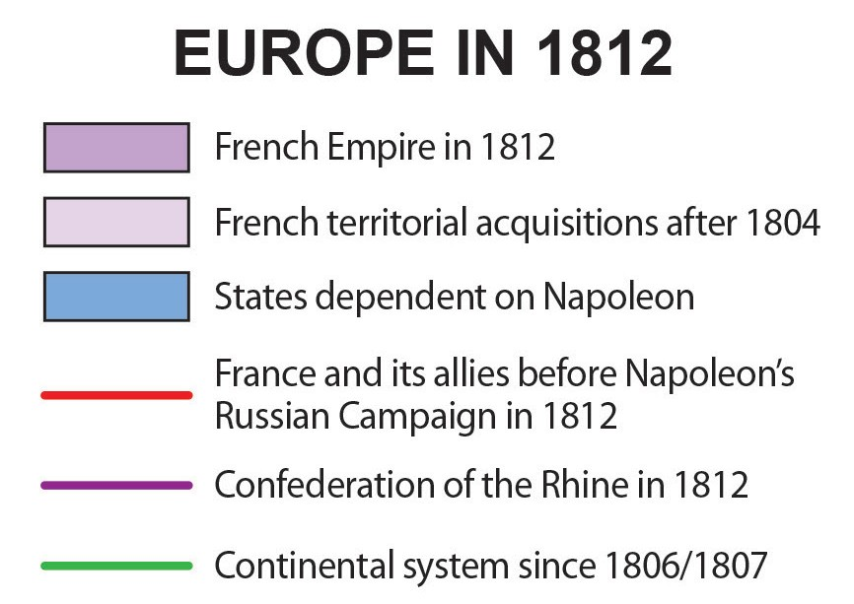

18 Chapter 1: War and Economy Chapter 1: War and Economy 19

The First World War: Total War
The successive wars following the French Revolution highlighted the importance of mobilizing different sections of a society to fight a protracted conflict. During the First World War, belligerents mobilized all resources of the societies to fight; all combatants and non-combatants were involved in the war; every bit of resources were prioritized for fighting. “Total War”, as a way of organizing societies to fight, has predated the First World War, but the concept of “total war” only became widely discussed after the First World War.

In a “total war”, the ability of the state to mobilize the society was seen as the key to victory. Apart from personnel mobilization, economic mobilization is also crucial. When the First World War broke out, all European belligerents, though to varying extent, had already experienced substantial industrialization. The infrastructure and technology brought by the Industrial Revolution greatly enhanced the capability of all belligerents to mobilize their economy. Thus, the level of economic mobilization reached an unprecedented level. Moreover, in order to better utilize the precious resources, all governments tightened their grasp of the national economy through institutional and legal means. For example, Britain passed the Defence of the Realm Act (DORA, 1914) right after the outbreak of war, which permitted the government to requisite private properties for the war effort. In 1915, the British government established the Ministry of Munition to coordinate the government, the armed forces, and the businesses. As Britain was also able to maintain its maritime trade, its wartime economy went relatively smooth during the war.

▲ Figure 1.4: A cartoon published in 1915, which entitled “Delivering the goods”. It depicted that Lloyd George charged with his horses “Labour” and “Capital” as they pull the Munitions of War carriage from a factory. (© Punch Limited)

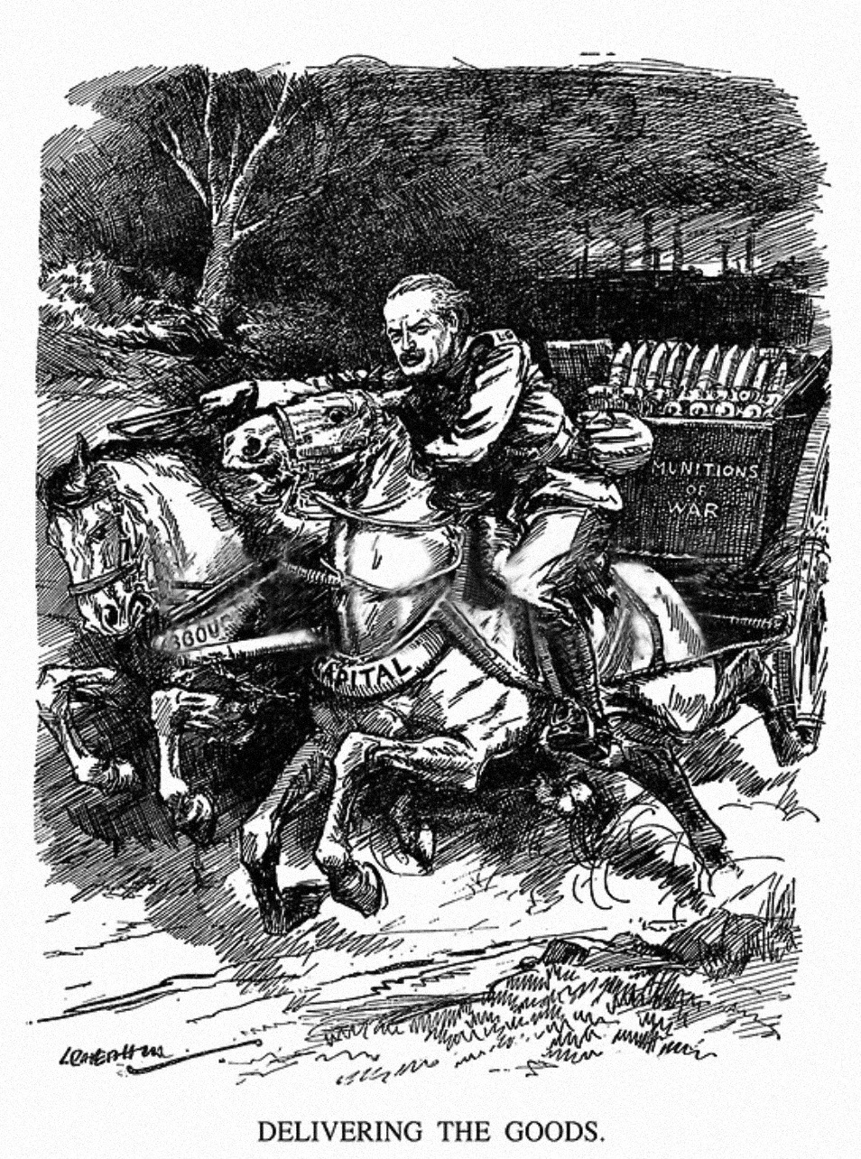
There were several main dimensions in economic mobilization during the First World War: manpower, food, raw materials, and industry. As the war turned into a stalemate, governments soon faced the problem of labor or food shortage. There were two main reasons behind it, firstly, a large number of agricultural workers were conscripted, drastically reducing agricultural labor supply and hence agricultural production. As a result, nations had to rely on imported food, which was not without difficulties: lack of foreign reserves to conduct international trade, trade disruption, or coastal blockade by the enemies. A typical example was the unrestricted submarine warfare launched by the Germans, which greatly disrupted British trade. As the supply of food became unstable, the urban population started to feel the peril of famine. The governments could not let famine happen, since it would affect national morale, disrupt ammunition production, or even lead to

20 Chapter 1: War and Economy Chapter 1: War and Economy 21

revolutions. One common solution was to set up centralized rationing systems, controlling the distribution of essential foodstuff and raw materials, and introducing price control. However, when the supply of food and raw materials dwindled, even rationing could not save the country from disturbance. The Turnip Winter in Germany (1916-1917), in which German citizens experienced severe hardship, was but one tragic example.

Apart from food, the belligerent states soon found themselves lacking in weapons and ammunition. For example, Britain experienced a “shell scandal”iii in 1915 that led to the collapse of the cabinet. The only way to increase weapon and ammunition supply was to expand production, but all nations were short of labor, raw material, and factory space. The cause of labor shortage, similar to the cause of food shortage, was the result of mass conscription of workers. France conscripted 2.9 million workers when the war started and sent another 2.7 million to the battlefield ten months later; in total, they amounted to 1/3 of her labor force. In order to fill the labor demand, the governments hurriedly recruited labor from rural areas, and Britain started to hire women for civilian jobs. However, since they were unskilled, their productivity was unavoidably low. Some factories then started to divide the production process further, so that the less-skilled labor could produce quickly. For raw materials, all nations, on the one hand, increased their volume of import from other neutral countries; on the other hand, they further exploited their domestic natural resources, such as coal and iron ore. Furthermore, they attempted to find replacements for some valuable resources. For example, the Germans experimented on synthetic nitrate, hoping to cope with the tremendous demand for fixed nitrogen from both agricultural and industrial sectors. Lastly, the governments continuously placed orders with the private sector, using up all of their production capacity; at the same time, they tried to convert civilian factories into military factories, hoping to cope with the enormous demand for weapons and ammunition.

It is intuitive to conclude, from the above paragraphs, that a nation’s economic mobilization capability is commensurate to the size of the population and the territory of a nation. Looking at the data of the First World War, the Entente Powers enjoyed a great advantage in terms of economic strength. When the war started in 1914, the Entente Powers had a population of 793.3 million and 67.5 million square kilometers of territory; while the Central Powers had a population of only
151.3 million and 5.9 million square kilometers of territory. Looking from an economic point of view, Germany was doomed when she could not defeat France in six weeks as planned, as the war soon turned into a war of attrition.

▲ Figure 1.5: “The Cost of the War,” Le Petit Journal Aug 1919. ( Source gallica.bnf.fr / Bibliothèque nationale de France )

Nevertheless, the size of the population and the territory do not always reflect the economic strength of a nation; its level of economic development and the ability to organize should also be considered. A decentralized and less developed country, even if she has a huge population and a vast territory, is incapable of quickly converting its economic strength to military strength. Firstly, the population of a less developed country might be mainly made up of subsistence farmers who cannot be quickly mobilized, without threatening domestic food production. Secondly, less developed countries might lack infrastructures like railways or roads, so even if they had a vast territory or large deposits of resources, they might not have the means to mobilize them. Thirdly, less developed countries generally lack an efficient bureaucracy and a mature state-business relationship, which are essential for the efficient distribution of resources. Furthermore, the less developed countries lacked money to lubricate the process of mobilization. In the First World

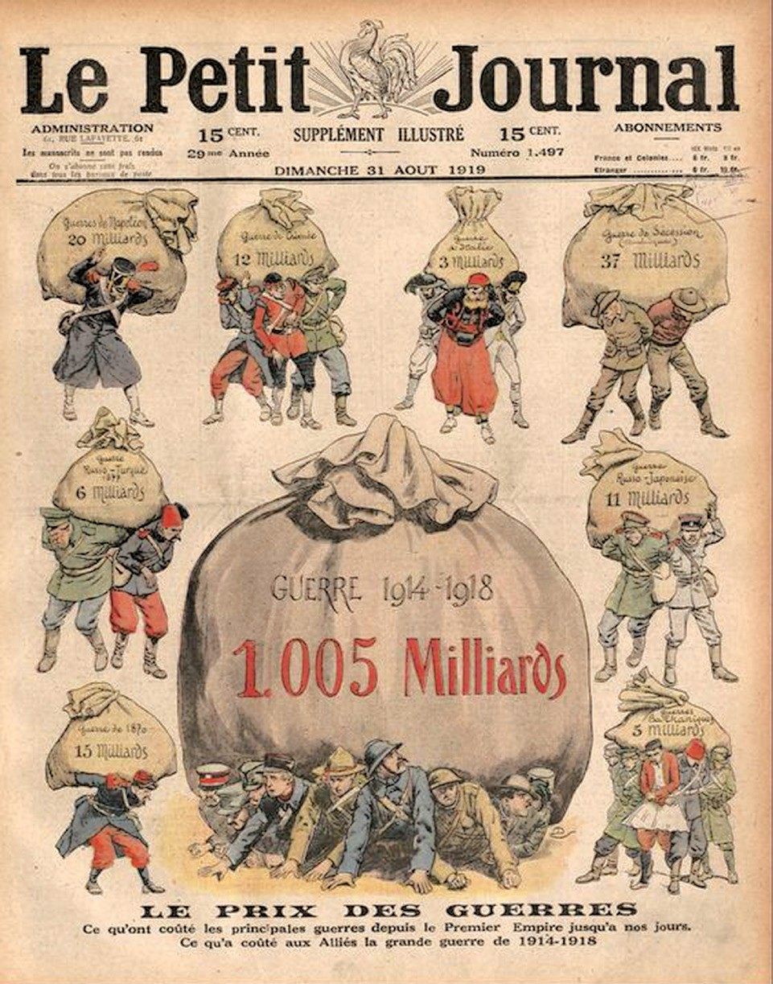
22 Chapter 1: War and Economy Chapter 1: War and Economy 23

her per capita GDP was only $1,488, or less than 1/3 of that of Britain and half of Germany. Consequently, Russia was one of the first belligerents whose economy collapsed and was forced to quit the war. Fortunate enough for the Entente Powers, the new ally that replaced Russia, the USA, was the most industrial and developed country of the world. Thus, the economic gap between the two camps was further widened.
War, Russia is a typical less developed state trying to fight a modern industrial war
against Germany and Austria-Hungary. Despite her vast territory and population,
and they made up 40% of the increase in labor supply. The increase in working
hours, from 43.9 hours per week in 1940 to 47 hours per week in 1944, further

The economic factor played a crucial role in the First World War. Some even contend that the result of the war is decided more by economic factors than the military. They argue that, when Germany surrendered, her army was still capable of fighting. Instead, it was the collapse of her economy that forced Imperial Germany to surrender. However, given the internal and external pressure facing Germany at that time, it is debatable that German forces could sustain the war for long.

The Second World War: War of Production
By the end of 1918, people believed that they had just survived the bloodiest war ever. In less than two decades, however, another world war broke out. In terms of duration, the number of participating nations, casualties, and economic losses, the Second World War far surpassed the First World War. However, looking from an economic point of view, the two wars are similar: the more productive side wins. Simply speaking, the GDP of the US in 1938 was 800 billion, while Nazi Germany, at her peak, had a GDP of about 400 billion, not to mention the GDP of the US reached 1,500 billion in 1944. The economic disparity was even more astonishing when looking at their military production figures. Germany produced 46,000 tanks and self-propelled gun (SPG)iv from 1939 to May 1945; the US produced 99,000 from December 1941 to August 1945; the Soviet Union, joining the war slightly earlier than the US, produced 102,800. However, it should not be omitted the fact that while Germany and the USSR put most of their resources in the army, the Americans were simultaneously fighting Japan on the Pacific. The US dockyard produced 8,812 ocean-going naval vessels during the war, a great contrast to Japan, which only produced 589 ocean-going vessels from April 1939 onward.
increased the labor supply. By reallocating workers from low-working-hour, low- efficiency, and lowly paid positions to more efficient and better-paid factories, the labor supply in the USA was boosted up to another level. On the other hand, to ensure employment, the US government invested a large amount of capital, building new factories and encouraging existing civilian factories to transform into munition factoriesv.

Productivity was also crucial, and American factories were famous for high efficiency. To achieve mass production, the Americans started with the weapon design. Unlike the craft production adopted by Germany and Japan, American weapons were highly standardized, so the factories only have to produce several types of components in large quantities. Mass production allowed the factories to enjoy economies of scale. Furthermore, factories made extensive use of machinery and break up their production procedures, allowing unskilled labor to get used to their position quickly. As a result, though Americans might not have highly sophisticated weapons, they enjoyed an overwhelming advantage in quantity and in terms of logistics.

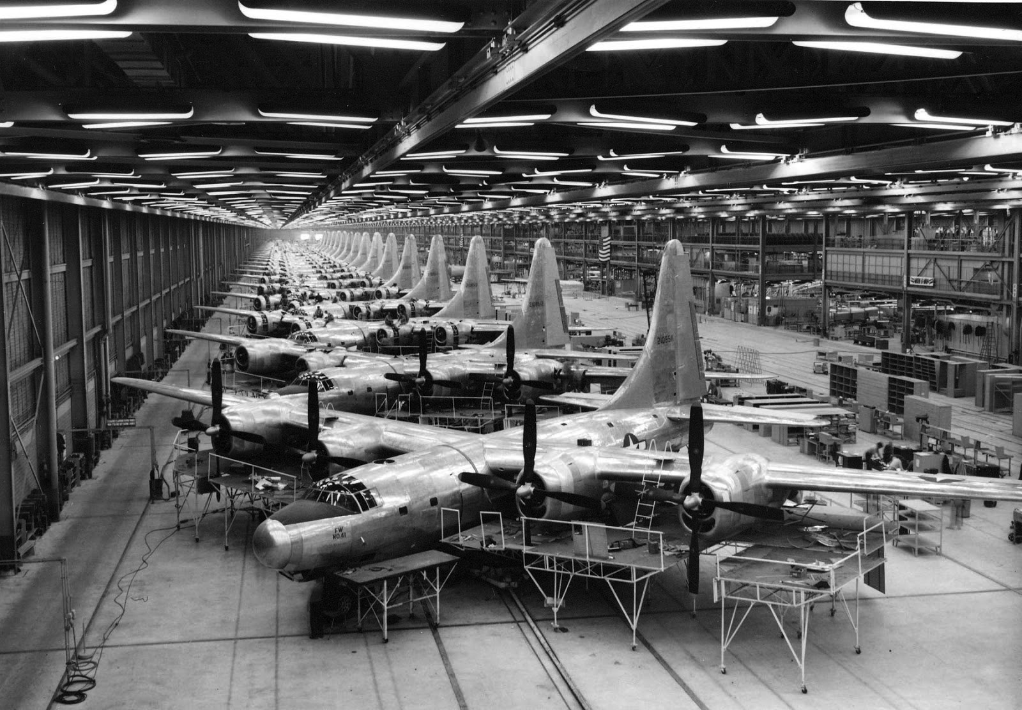
How, then, did America mobilize her industry to exploit her economic strength, achieving this scale of production? Here involved three production factors: labor, capital, and productivity. America, which was just recovering from the Great
Depression, had a large pool of skilled labor. Among them, 7.5 million were hired, ▲ Figure 1.6: Mass production of bombers in the USA during WWII. (USAF, Public domain, via Wikimedia
Commons)
24 Chapter 1: War and Economy Chapter 1: War and Economy 25

materials in the middle of the war, and finally reached the brink of economic collapse before surrender. The economy of Nazi Germany, pinched by imperfect resources allocation policy, maritime blockade of the Allies, and the scarcity of strategic raw materials (such as oil) within the territory under her control, also broke down during the last phase of the war. Britain’s economy was comparatively better off than Japan and Germany, partly thanks to the contribution of the USA and other territories of the British Empire, such as the Lend-Lease Program (1941). Still, while the British had not experienced widespread hunger, those living in Bengal, controlled by the British at that time, were not as fortunate. In 1943, a severe famine broke out in Bengal because of faulty policies, disruption of trade, and lack of transport, costing more than three million lives.

▲ Figure 1.7: Mass production of American tanks during WWII. For more information about the production of tank, please refer to: https://digitalcollections.detroitpubliclibrary.org/islandora/object/islandora%3A201195 (Courtesy of the National Automotive History Collection, Detroit Public Library)

Of course, the “production miracle” did not happen on its own, it had to be organized and coordinated by the government. The American government agency that was responsible for the job was the War Production Board. The War Production Board was established in January 1942. Its duty included overseeing the transition of civilian factories to military factories, distributing war resources, and minimizing nonessential production. Moreover, it was also responsible for the rationing of several types of strategic resources such as gasoline and rubber. The American advantage in materials is the best evidence showing how successful the Board was. Similar agencies could also be found in other nations, such as the British Ministry of War Production that was established in February 1942.

However, America’s well-organized wartime economic policy was an exceptional case. Most of the belligerents, sooner or later, faced economic problems. Japan, suffering from chaotic wartime economic planning and, more importantly, a constant lack of transport, started to feel the problem of insufficient strategic

Summary
As the passages above illustrated, the economic factor of war was increasingly important in modern times. The phenomenon could be attributed to two main factors: firstly, the scale of war increased persistently in the recent centuries, culminating in the Second World War; secondly, as the scale of war and the sophistication of weapons multiplied, the amount of resources war consumed also increased. Hence, economic strength became one of the determining factors of the outcome of wars. The economic strength discussed here included not only production, but also credibility, control of trade, and the relationship between the state and the society. Moreover, as governments’ control over the economy grew, their control over the society also tightened. This is a side effect of war that should not be overlooked. Still, one should remember that while the economic factor was important, war cannot be won by economic power alone, and sometimes richer countries lose wars that were apparently impossible to lose. Thus, one has to develop a more comprehensive understanding of wars in history.

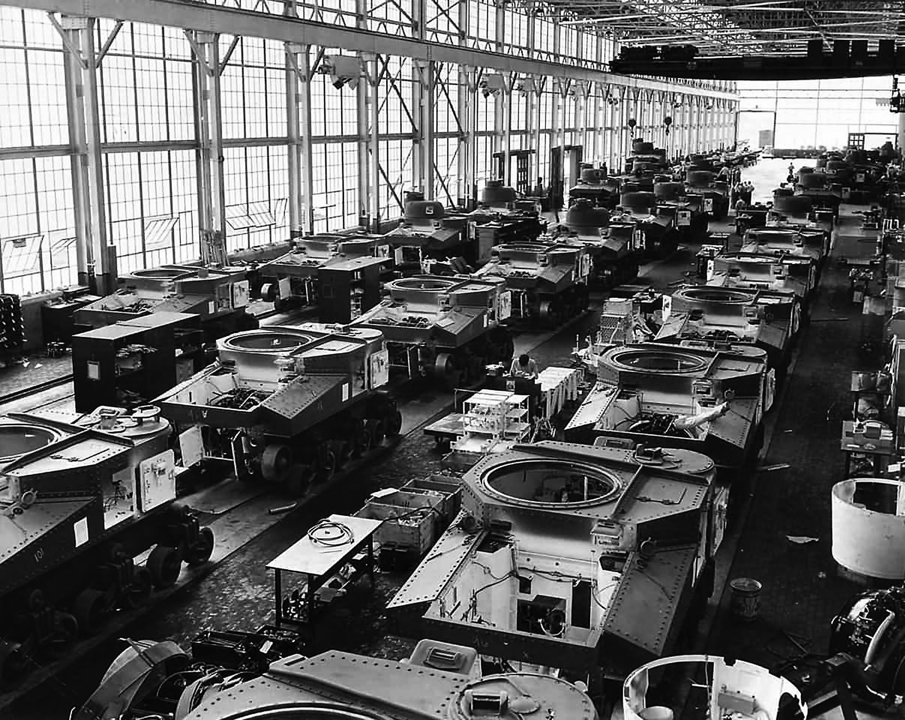
26 Chapter 1: War and Economy Chapter 1: War and Economy 27

Suggested Readings:
Bacon, Benjamin. Sinews of War: How Technology, Industry, and Transportation Won the Civil War. Novato, Calif.: Presidio, 1997.
Black, Jeremy. War and the World: Military Power and the Fate of Continents 1450-2000.
New Haven, Conn.: Yale University Press, 1998.
Broadberry, Stephen and Harrison, Mark (ed.). The Economics of World War I. Cambridge: Cambridge University Press, 2005.
Davis, Lance; Engerman, Stanley. Naval Blockades in Peace and War: An Economic History since 1750. Cambridge; New York: Cambridge University Press, 2012.
Harrison, Mark (ed.). The Economics of World War II: Six Great Powers in International Comparison. Cambridge; New York: Cambridge University Press, 1998.
Kennedy, Paul. The Rise and Fall of the Great Powers. New York: Vintage Books, 1989.
Milward, Alan S. . War, Economy and Society, 1939-1945. History of the World Economy in the Twentieth Century; V. 5. Berkeley: University of California Press, 1979.
尼爾‧弗格森（著）、區立遠（譯）。《第一次世界大戰，1914-1918 戰爭的悲憐》
。台北：廣場出版，2016。
莉琪‧科林漢（著）、張馨方（譯）。《戰爭的滋味：為食物而戰，重整國際秩序的第二次世界大戰》。台北：麥田，2021。
讓．洛培茲、文森．貝爾納、尼可拉．奧本（著）、洪夏天（譯）。《用資訊圖表讀懂第二次世界大戰》。台北：商周出版，2019。

Meaning of terms:
- Limited war: A limited war is one in which the belligerents do not devote all of the resources, including human, industrial, agricultural, military, natural, technological, or otherwise in it. Sometimes the war goals would also be limited. Many of the dynastic wars in Europe during the 17th and 18th centuries were limited wars, compared to the Thirty Years’ War, the Napoleonic Wars, and the two World Wars.
- Continental System: The blockade designed by Napoleon to paralyze Britain through the destruction of British commerce during the Napoleonic Wars. Under it, neutrals and French allies were not to trade with the British.
- “Shell scandal”: In May 1915, the British media reported the lack of shells at the front and negative impact on the performance of the British forces. The subsequent controversy led to a restructuring of the British cabinet and the introduction of the Munitions of War Act 1915 that strengthened the cooperation between the government and the industries.
- Self-propelled gun (SPG): An artillery equipped with its own propulsion system to move towards its firing position. Various types of guns such as howitzer, mortar, cannon, anti-tank guns, rockets, and anti-aircraft guns could be mounted.
- Civilian factories to transform into munition factories: For example, during the war, the civilian vehicle maker Ford built military vehicles and aircraft for the American armed forces.

28 Chapter 1: War and Economy Chapter 1: War and Economy 29

Chapter 2
War and International Law

Chapter 2: War and International Law

Introduction
The law of war is part of international laws that regulate the conditions for war (jus ad bellum) and the conduct of belligerents during wartime (jus in bello). The law of war was, despite its importance, not always respected or observed because warring parties often prioritized their strategic and tactical needs, and the laws are difficult to enforce. As a result, its effectiveness largely depends on the existence of regulated world order, in which the nations would be willing and able to intervene and enforce the law when it is violated.

The law of war was not written at a particular time. It is the amalgam of all the treaties and conventions signed by nations from the second half of the 19th century. Some of the principles espoused by the law evolved from traditions of war. Thus, it should be noted that definition of “war crimes” changed over time, and acts that were not seen as criminal would be seen as such in different times. Before 1949, sovereign states were the main force that maintained the law of war; after 1949, the Law of War was also enforced by international organizations and parties.
work The Freedom of the Seas in 1609, in which he advocated that the sea was international territory and set up rules on armed conflict on high seas. As the Thirty Years’ Warii (1618-1648) raged on, Grotius compiled his first codified law of war — De Jure Belli ac Pacis (On the Law of War and Peace) in 1625. Grotius suggested that customs and moral traditions on the conduct of war existed but were never strictly observed; hence, he compiled the law code. The first two volumes of his work discussed the criteria of starting a just war, and the third volume analysed the rules of engagement. His work would have had little value had the belligerents not observe the regulations. However, it was not until the 19th century that the European started to systematically explore ways to regulate acts of war.

The Origin of the Law of War
Regulations on armed conflict exist for a long time in human history. The earliest law of war might be the Mahabharata of India dated back in 3-5th Century BC. The Mahabharata regulated various aspects of fighting, including the use of cavalry, conducts during sieges, and the treatment of civilians and their properties. It also stated that war should be waged for the sake of conquest rather than merely killing,

▲ Figure 2.1: Cover of Hugo Grotius’ The Freedom of the Seas (in Latin), 1609. (Hugo Grotius., Public domain, via Wikimedia Commons)
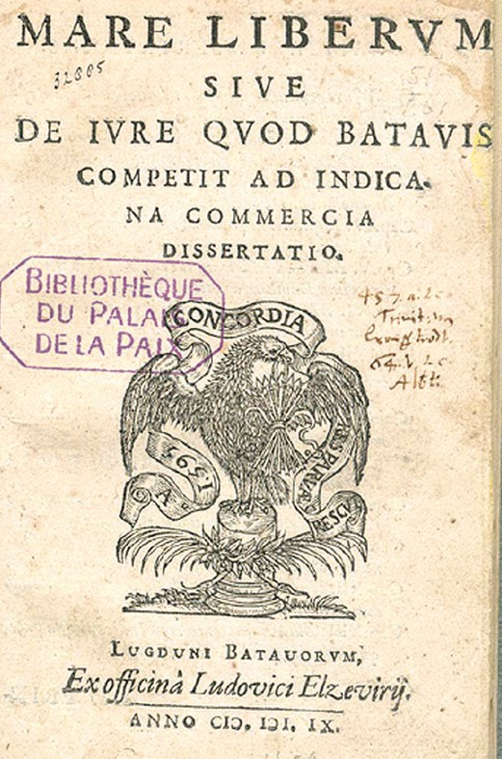 |  | 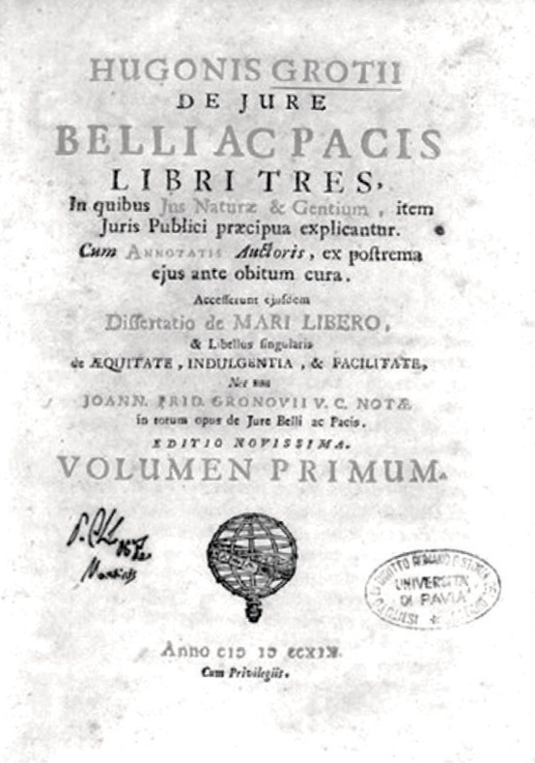

▲ Figure 2.2: Cover of Hugo Grotius’ De Jure Belli ac Pacis (in Latin), 1719 version. (Hugo Grotius, Public domain, via Wikimedia Commons)

suggesting the need for a rational purpose for war. Regulations on the conduct of war also emerged in Christian Europe. Early Christian thinkers, including Saint Augustine (354-430) and Saint Thomas Aquinas (1225-1274), advocated the idea of ‘Just War’, which regulated the conduct of fighting and the cause of war. These
concepts were further elaborated later by the School of Salamancai. By then, the
law of war had yet to be codified.

It was not until the 17th century did the first systematic law of war appear, compiled by the Dutch jurist Hugo Grotius (1583-1645). Grotius finished his

Rules of Engagement
The rules of engagement regulate the actions of combatants, place restrictions on how one can fight, and forbid misbehaviors. There are also regulations on the treatment of prisoners of war and the wounded. Furthermore, they define legitimate combatants and regulate the treatment of neutral countriesiii or individuals. Similar to other laws of war, the rules of engagement are the accumulation of conventions and traditions.

The first set of rules governing the way of fighting was related to warfare at sea. In early modern Europe (late 15th century to late 18th century), armed conflicts were

32 Chapter 2: War and International Law Chapter 2: War and International Law 33

much more frequent at sea than on land; at the same time, since a third party was often absent on the high seas, atrocities were commonplace. Worse, neutral and commercial vessels were often caught up in these armed conflicts and became victims of atrocities. As a result, there had been calls for regulations on armed conflicts at sea. Finally, in 1856, 55 nations signed the Paris Declaration Respecting Maritime Law, which primarily dealt with the problem of privateers, but also set up new prize rules on neutral and belligerent vessels and goods.

Soon afterwards, the American Civil War (1861-1865) broke out, and President Abraham Lincoln (1809-1865, 1861-1865 in office) signed General Order No. 100 (1863), which outlined the rules of engagement of the Union forces. According to the order: ‘Men who take up arms against one another in public war do not cease on this account to be moral beings, responsible to one another and to God.’ Thus, it suggests that: ‘military necessity does not admit of cruelty...nor of torture to extort confessions. ’ The abovementioned lines suggest that all hostile actions that make the return to peace unnecessarily difficult should be prohibited. It also suggested that private properties and civilian lives were to be respected and protected, and prisoners of war had the right to remain silent. This general order became a reference of future rules of engagement.

▲ Figure 2.3: Lawrence massacre in 1863, one of the worst war crimes committed by the Confederate forces during the American Civil War. (Harper’s weekly, Public domain, via Wikimedia Commons)
In 1864, representatives of the nations gathered at Geneva, Switzerland, to sign the First Geneva Convention. According to the convention, ambulances and military hospitals shall be recognized as neutral, while they should have a distinctive and uniform flag; personnel should wear an armlet with a red cross on a white ground. Furthermore, wounded or sick combatants, to whatever nation they may belong, shall be collected and cared for. The latest (fourth) update of the convention took place in 1949. In 1874, invited by Czar Alexander II (1818-1881, r.1855-1881) of Russia, representatives gathered at Brussels, Belgium, and signed the Brussels Declaration. The highlight of the Declaration was Article 12, which stated that ‘the laws of war do not recognize in belligerents an unlimited power in the adoption of means of injuring the enemy.’ Under such principle, various issues were regulated, including injuring the enemy, laying sieges, the use of spies, occupation over hostile territory, treatments of the prisoners of war, sick, and wounded, taxations and requisitions on enemy territory, parlementaires, capitulations, and armistices.

In 1899, the nations gathered at the Hague again and held the first Hague Convention. The representatives signed three conventions, I: Convention for the Pacific Settlement of International Disputes; II: Convention with respect to the Laws and Customs of War on Land and; III: Convention for the Adaptation to Maritime Warfare. They also signed three non-binding declarations, I: Declaration concerning the Prohibition of the Discharge of Projectiles and Explosives from Balloons or by Other New Analogous Methods, II: Declaration concerning the Prohibition of the Use of Projectiles with the Sole Object to Spread Asphyxiating Poisonous Gases, III: Declaration concerning the Prohibition of the Use of Bullets which can Easily Expand or Change their Form inside the Human Body such as Bullets with a Hard Covering which does not Completely Cover the Core, or containing Indentations. The highlight of the convention was the banning of certain actions and weapons, such as the use of poisonous gas, ammunitions that could cause superfluous injury, and improper uses of a flag of truce. Furthermore, attacks or bombardments of undefended settlements are prohibited. The nations gathered again at the Hague in 1907 for the second Hague convention. Eleven conventions were signed, among them, three conventions (I: Convention for the Pacific Settlement of International Disputes; III: Convention relative to the Opening of Hostilities, and V: Convention relative to the Rights and Duties of Neutral Powers and Persons in case of War on Land) were particularly important, as these conventions governed the process of declarations of war and the treatment of neutral powers.

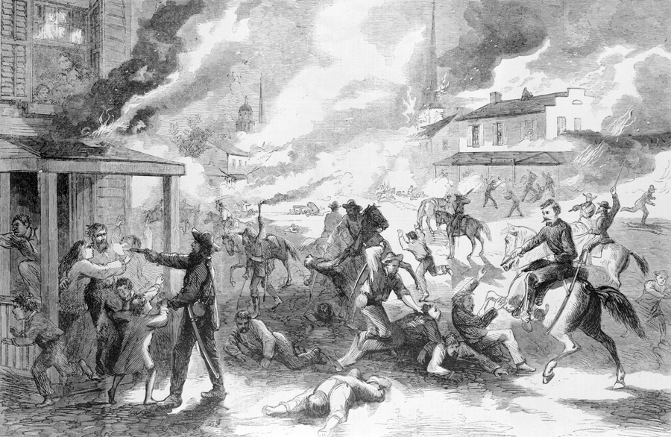

34 Chapter 2: War and International Law Chapter 2: War and International Law 35

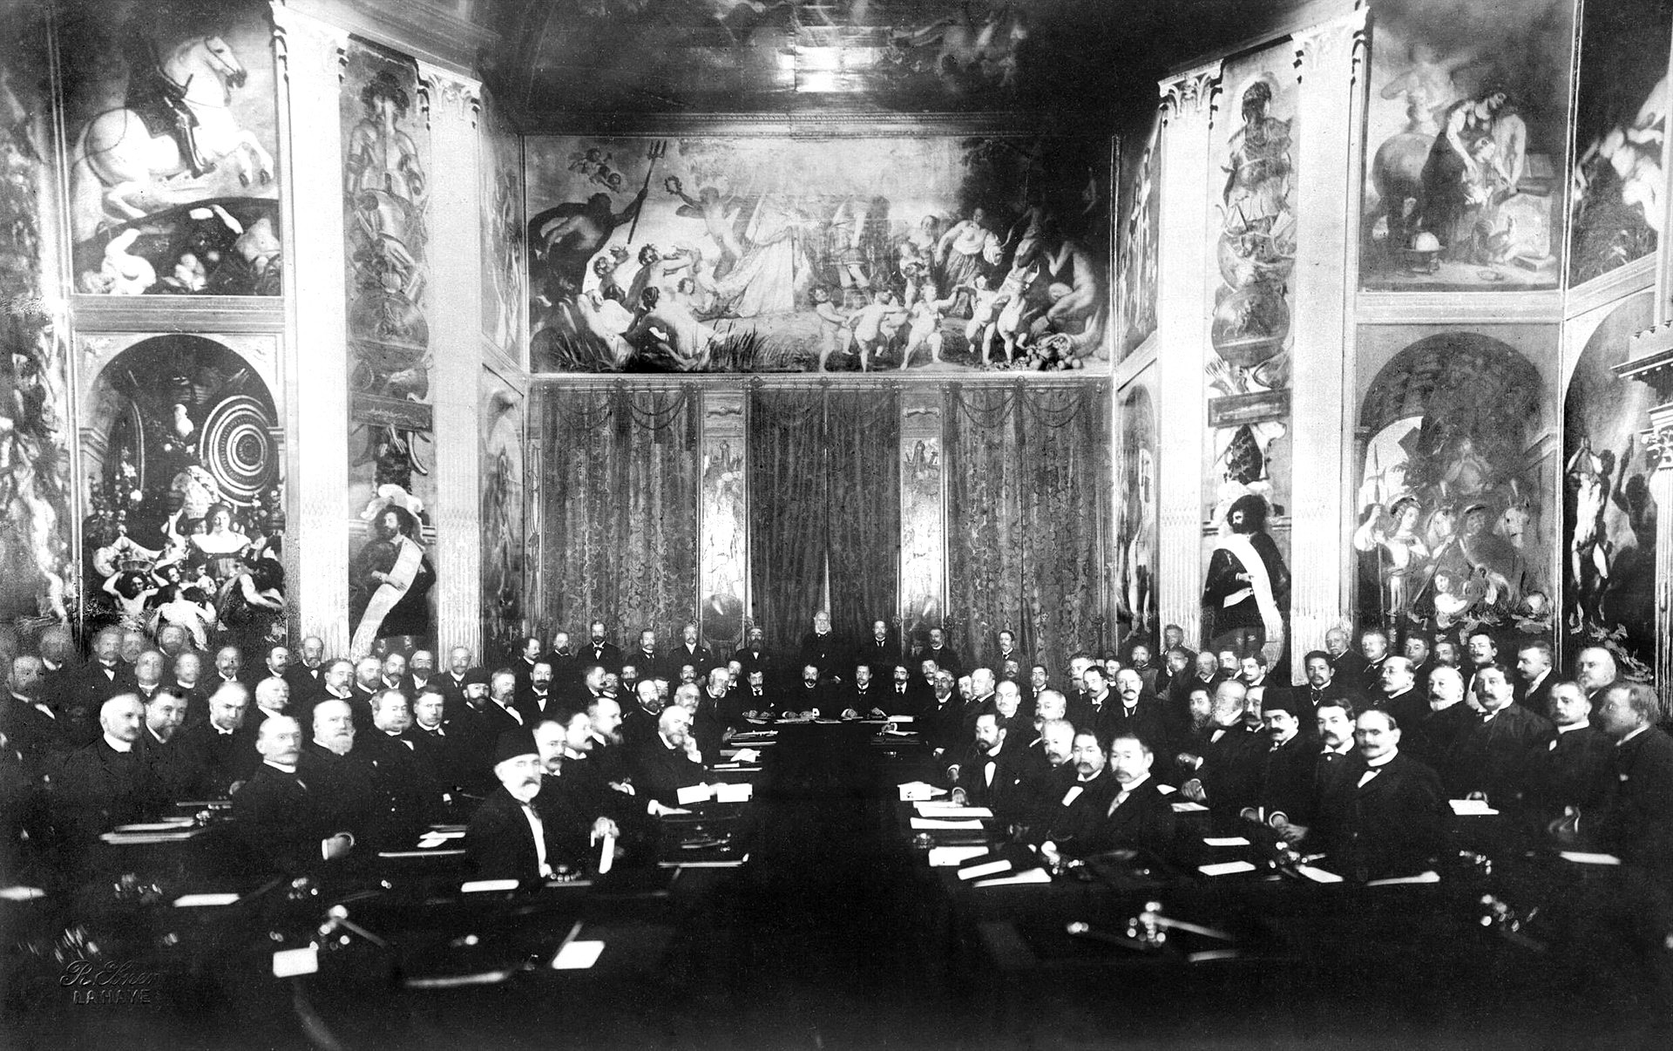However, with the absence of an enforcement agency, the conventions were of little effect. During the First World War, belligerents deployed poisonous gas, bombed cities, used expanding bulletsiv, and attacked commercial vessels. The resulting tragedies motivated the powers to establish the League of Nations that was supposed to keep peace and monitor the use of force. In 1928, the nations signed the Briand-Kellogg Pact, claiming that they ‘condemn recourse to war for the solution of international controversies’, and ‘renounce it, as an instrument of national policy in their relations with one another’. Thus, the signatories claimed that they would not actively start a war.

▲ Figure 2.4: The First Hague Conference in 1899. (© IWM HU 67224)

▲ Figure 2.5: Cover of the Hague Conventions and Declarations of 1899 and 1907, re-published in 1915. ( Internet Archive)
During the interwar period, more international conventions appeared to place limits on the rules of engagement. In 1923, the Hague Rules of Aerial Warfare was signed; the rules forbid attacks on parachuted aircrew and the bombing of the civilian population. The London Protocol on Submarine Warfare 1936 reiterated the prohibition on warships attacking merchant vessels. The Convention for the Protection of Civilian Populations Against New Engines of War 1938 restated that bombing civilians by bombers was strictly prohibited. However, as was what happened during the First World War, belligerents of the Second World War violated all these regulations, as no institution could enforce the signed and ratified conventions.

When the Second World War ended, the United Nations was formed and given the power to maintain peace and enforce the law of war. According to Article 42, Chapter VII of the United Nations Charterv, ‘[the United Nations] may take such action by air, sea, or land forces as may be necessary to maintain or restore international peace and security.’ Later, the fourth Geneva Convention was signed, which not only restated the previously agreed rules of engagement, but also prohibited/limited the use of biochemical weapons and mines.

Arms Limitation and Control
Military technology developed quickly since the 19th century, and the ‘progress’ posed much threat to humanity. Some weapons not only could cause mass destruction, but also bring inhumane pain and suffering to the victims. Hence, nations signed treaties that limit and prohibit the use of certain weapons. The first attempt was the Saint Petersburg Declaration of 1868, which forbade projectiles of a weight below 400g to be equipped with explosives or charged with fulminating

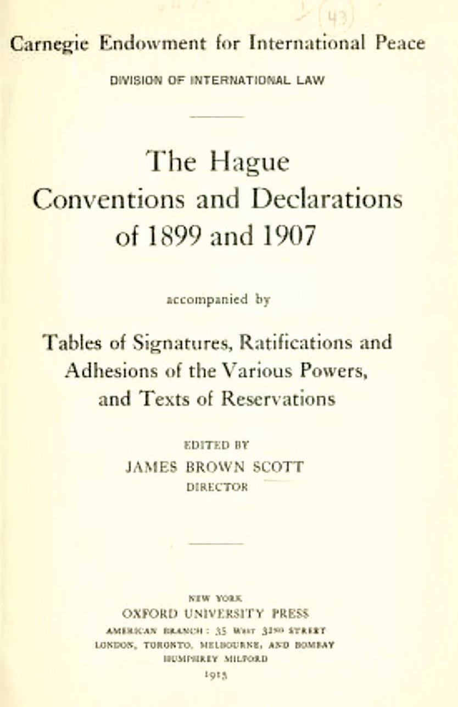
36 Chapter 2: War and International Law Chapter 2: War and International Law 37

or inflammable substances so that it would not cause unnecessary suffering to humans. Furthermore, as the armament race in the early 20th century built up great tensions among the powers, they concluded treaties after the First World War to limit the number of certain armaments of the major powers. The Washington Naval Treaty of 1922, for example, limited the total capital ship tonnage of Britain, the United States, France, Italy, and Japan. The size of naval guns was also regulated.

After the Second World War, the world entered the nuclear age. As more nations developed nuclear weapons, regulations became an important task for all nations. Finally in 1968, as the tensions between the two superpowers — the US and the USSR — alleviated, 62 nations signed the Nuclear Non-Proliferation Treatyvi. The nations that possessed nuclear weapons agreed that they would not transfer the nuclear weapon technology to those that had not; the latter also guaranteed that they would not produce or acquire nuclear weapons. Thereafter, the United States and the USSR signed the Anti-Ballistic Missile Treaty in 1972, which limited the number of nuclear weapons they possessed and regulated the location of their deployment. However, some nations, including India, Pakistan, and Israel, did not sign the Nuclear Non-Proliferation treaty, and the former two nations openly admitted that they have nuclear weapons.

War Crimes
War crimes were actions that violated the law of war and rules of engagement. Usually, they involved atrocities on civilians or enemy military personnel. One of the earliest war crime tribunals was a provisional court set up by the Holy Roman Empire in 1474. Peter von Hagenbach (1420-1474) was accused of allowing his men to murder and rape the civilians while putting down a rebellion in Burgundy. The court adjudged that he should be beheaded, suggesting that ‘he as a knight was deemed to have a duty to prevent [the atrocities].’ This established the precedent of holding commanding officers responsible for war crimes committed by ordinary soldiers.
▲ Figure 2.6: Trial of Hagenbach. (Diebold Schilling the Elder, Public domain, via Wikimedia Commons)

More formal and detailed war crime tribunals only emerged in the 20th century. After the First World War, a number of trials were held. Among them the Leipzig War Crimes Trials (1921) were the most famous, as several German soldiers were convicted. However, given the scale and duration of the conflict the Leipzig Trials were clearly inadequate in ensuring justice and setting up precedents.

During the Second World War, armed forces of the belligerent powers committed numerous war crimes, particularly those of the Nazi Germany and Imperial Japan. In October 1942, President Roosevelt declared that ‘the intention of this Government that the successful close of the war shall include provision for the surrender to the United Nations of war criminals.’ In December, when giving a speech about the purge of the Jews, he declared that ‘those responsible for these crimes shall not escape retribution, and to press on with the necessary practical measures to this end.’ In September 1943, the USSR also delivered the Moscow Declaration, which suggested that ‘[war criminals] will be sent back to the countries in which their abominable deeds were done... [those] whose offences

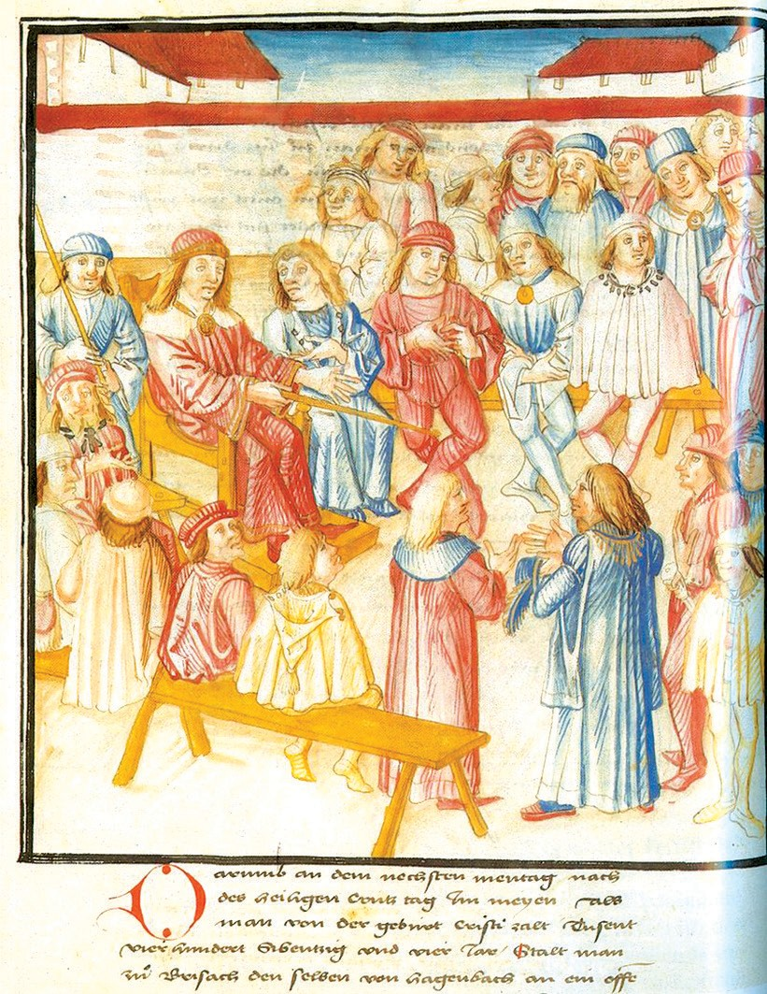
38 Chapter 2: War and International Law Chapter 2: War and International Law 39

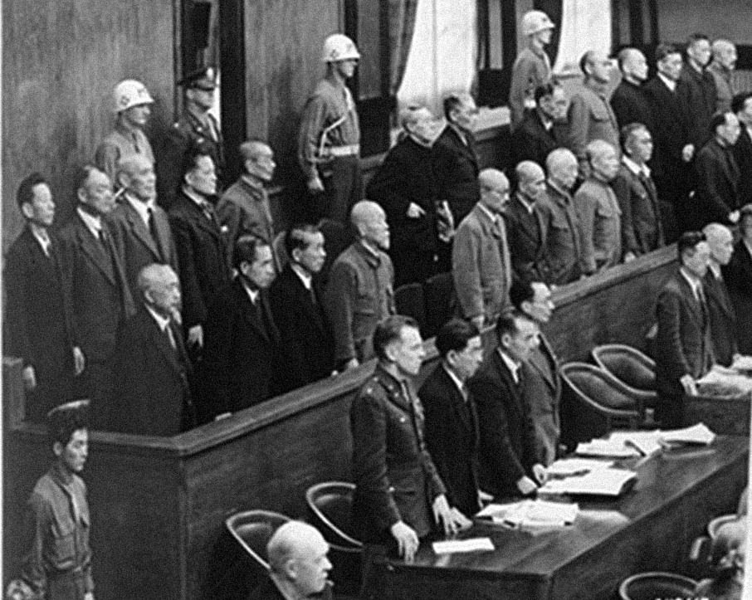have no particular geographical localization and who will be punished by the joint decision of the Governments of the Allies.’ A month later, the United Nations War Crime Commission (1943-1948) was formed; its duty was to investigate and record the evidence of war crimes and identify where possible the individuals who are responsible. In July 1945, leaders of the US, USSR, and China delivered the Potsdam Proclamation, which stated that ‘We do not intend that the Japanese will be enslaved as a race or destroyed as a nation, but stern justice shall be meted out to all war criminals, including those who have visited cruelties upon our prisoners.’

In August 1945, the Charter of the International Military Tribunal, which was known as the London Charter, was issued. It was the agreement for the prosecution and punishment of the major war criminals in Europe. Later in January 1946, a similar Tokyo Charter was issued. What followed was the two international Tribunals: Nuremberg and Tokyo. After ten months of trials, the judge issued a 250 pages long judgment, which declared that ‘he who violates the laws of war cannot obtain immunity while acting in pursuance of the authority of the state if the state in authorizing action moves outside its competence under international law.’ Eventually, several war criminals were sentenced to death, while some others were imprisoned. In the International Military Tribunal for the Far Eastvii, seven criminals were sentenced to death, including Tojo Hideki (1884-1948) and Itagaki Seishiro (1885-1948). Apart from these major tribunals, there were also tribunals of Class B and C war criminals who committed atrocities during the war. For example, between 1946 and 1948, Hong Kong held 46 war crime trials, involving 123 individuals.

▲ Figure 2.7: War criminals in the dock of the International Military Tribunal for the Far East (two rows at the back).
For more information, please refer to http://zxsl.nlc.cn/ jeecms/djsp.jhtml (Chinese only) (National Library of China . National Digital Library of China)

When it came to the second half of the 20th century, courts of war criminals were occasionally held. For example, International Criminal Tribunal for the former Yugoslavia (1993-2017) and International Criminal Tribunal for Rwanda (1994- 2015) were organized to deal with the violations of human rights and atrocities that took place in Yugoslavia and Rwanda. To establish a permanent international body to deal with war crimes and violations of human rights by the states, the International Criminal Court was set up in 2002, based on the Rome Statute of 1998 signed by 139 countries.

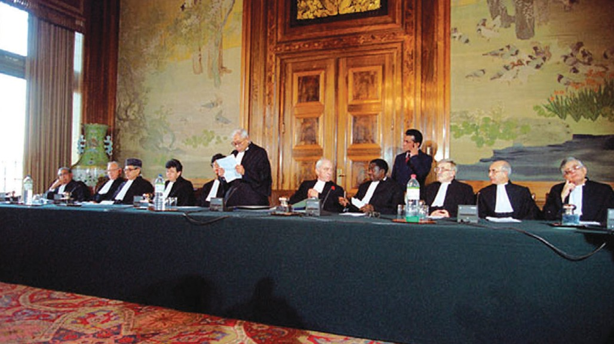

▲ Figure 2.8: Inauguration of the International Criminal Tribunal for the former Yugoslavia in 1993. The 11 judges of the Tribunal met at Hague, The Netherlands. ( “Material obtained on 2 May 2022 from the website of the United Nations Audiovisual Library of International Law, located at http://www.un.org/law/avl .”)

40 Chapter 2: War and International Law Chapter 2: War and International Law 41

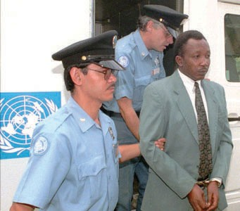▲ Figure 2.9: Genocide trial of the International Criminal Tribunal for Rwanda in 1997. (“Material obtained on 2 May 2022 from the website of the United Nations Audiovisual Library of International Law, located at http://www.un.org/law/avl .”)
傑里米‧布萊克(著)。《大屠殺：歷史與記憶》。北京：中央編譯出版社，2018。
瑪格蕾特‧麥克米蘭(著)、曹嬿恆(譯)。《戰爭：暴力、衝突與動盪如何形塑人類與社會》。台北：商周出版，2021。
瑪格蕾特‧麥克米蘭。《巴黎和會：締造和平還是重啟戰爭？重塑世界新秩序的關鍵 180 天》。台北：麥田，2019。
Meaning of terms:
i The School of Salamanca: A school of thought emerged in Spain during the Renaissance, popular especially among Spanish theologians and rooted in the

Summary
Although the International law of war was originated from Europe, it was globalized because of the two world wars. As international law of war is not enforced by any sovereign state, it works differently from local laws. It worked best when the nations believed that it was in their interest to abide by them. Unfortunately, not all states recognized the importance of the law of war, which was never fully recognized or observed, especially the major powers that possess nuclear weapons. As a result, there has been a vast geographical and cultural discrepancy in the implementation of international standards.

Suggested Readings:
Best, Geoffrey. Humanity in Warfare. New York: Columbia University Press, 1980.
Crossland, James. War, Law and Humanity the Campaign to Control Warfare, 1853-1914. London : Bloomsbury Academic, 2018.
Sorabji, Richard., and David. Rodin. The Ethics of War: Shared Problems in Different Traditions. Aldershot, England; Burlington, VT: Ashgate Pub., 2006.
intellectual and pedagogical work of Francisco de Vitoria. It was a response to the rise of humanism, the Protestant Reformation, and the new geographical discoveries.
- The Thirty Years’ War (1618-1648): It was the most devastating war in Europe before the First World War. The origin of the war was the attempt of the Bohemians to breakaway from the Hapsburg rule. Almost all European states had participated in the war, where it took place largely within the territory of the Holy Roman Empire. The war-weary European states finally signed the Treaty of Westphalia in 1648. It was estimated that the war led to the death of over 9,000,000, with most of them civilians.
- Neutral country: A state that is neutral towards belligerents in a specific war or holds itself as permanently neutral in all future conflicts. It enjoys protection under the law of war from belligerent actions to a greater extent than other non- combatants.
- Expanding bullets: A kind of ammunition that exploded upon impact to cause greater wound on men and animals.
- Charter of the United Nations: It is the foundational treaty of the United Nations. It was signed in 1945. It stipulates the objectives of the United Nations, its organization, and the rights and duties of the member states.
- Nuclear Non-Proliferation Treaty: An international treaty signed in July 1968 by the US, the USSR, Britain, and other nations. It was about the reduction of nuclear weapons, stopping the spread of nuclear weapons technology, and the promotion of international cooperation over the peaceful use of nuclear power.
- The International Military Tribunal for the Far East: After the Second World War, the victorious Allied Powers set up the International Military Tribunal for the Far East in Tokyo and elsewhere to try the Japanese war criminal of different categories.

42 Chapter 2: War and International Law Chapter 2: War and International Law 43

Chapter 3
War and Medicine

Introduction
The Greek philosopher and physician Hippocrates once said that “war is the only proper school for a surgeon”. Indeed, there is a close relationship between war and medical care. On the one hand, advancements in medical science prolong wars by allowing more wounded soldiers to be treated so that they could return to the fight; on the other hand, medical services reduce human suffering caused by war. Combatants suffer from not only physical injuries but also diseases and mental illnesses. Throughout modern times, escalation of the scale of wars boosts developments in medicine and medical science.

This chapter provides an overview of the development of medical science and medicine in modern wars. The first part deals with the emergence of the modern nursing system in the Crimean War in the mid-19th century. It then deals with the founding of the Red-Cross after the Austro-French Piedmontese War, another brutal war that triggered the formation of an international organization to provide humanitarian aid to people in war. The third part inspects the relationship between tropical diseases and imperialism, illustrating how the cure of tropical diseases benefited to the expansion of empires. Until the early 20th century, more soldiers died of wounds and diseases than those who were killed in action. It was not until the above-mentioned developments started to have an apparent effect that this was no longer the case. Lastly, the medical services and battlefield medical care, and the impact of the Spanish Flu on the post-war world are discussed.

Emergence of a Modern Nursing System: the Crimean War
The Crimean War (1854-1856) was fought between the Russian Empire and the coalition of Britain and France, which dispatched troops to the Black Sea with only little medical provisions and amenities. Illness explained the death of around 17,500 British and 75,000 French soldiers. Although the war was won by the British and the French, it created much unnecessary suffering. This also gave birth to a revolution of health care and the emergence of modern nursing system.

During the mid-19th century, the British public had a higher expectation in the government of its ability to take care of the wounded and the sick soldiers than during the previous wars such as the Napoleonic Wars. Their demand pushed
to the Scutari Military Hospital in Turkey in 1854. Upon arrival, she discovered the appalling state of the hospital. Hygiene was bad, and basic amenities were lacking. Nightingale brought daily necessities to the hospital and arranged the delivery of British food to Turkey. The nurse team involved in cleaning the wounds of the soldiers, keeping them clean and preventing infection. One scholar suggests that the overall mortality rate of the inpatients of the hospitals had dropped to 2.2 percent from 42 percent towards the end of the war, partly as the result of the work of Nightingale and the medical staff.

The involvement of nursing staff in medical care during the Crimean War paved the way for the introduction of a similar system in public health services. After the war, a commission found that the veterans’ life expectancy was shorter than civilians. Nightingale, therefore, shifted her attention to the promotion of public health knowledge. She wrote the pamphlet Notes to Nursing, based on her experience of the Crimean War. The pamphlet helped civilians to understand the basics of personal and family hygiene and first aid. She also took part in hospital design and construction. Hospitals set up at that time had been benefited from her input. A more long-lasting impact was the establishment of nurse training centers in London. A fund of 50,000 pounds was raised by Nightingale, who set up a School of Nursing and a training center at St. Thomas Hospital in London. Her works set the standard of nursing and enhanced its status, from a practice of untrained helpers to one of professionalism. This marked a keystone for the development of the modern nursing system.
Chapter 3: War and Medicine
the government to allow Florence Nightingale (1820-1910)i, a volunteer, to the
front to provide medical care to the troops. Nightingale had brought 84 nurses

Medical Service as Responsibility: The Red Cross and the Geneva Convention of 1864
The emergence of the Red Cross was a reflection of the brutality of modern warfare by the European community after the Austro-France Piedmontese War of 1859. Although the Red Cross was unable to prevent wars, it has been responsible for providing medical care, protection, and comfort in war zones for the past 150 years or so. As of 2019, the Red Cross is an international organization with over 100 member countries that had commitments across the globe.

The Austro-France Piedmontese War was fought between two great powers of Europe, Austria and France with its Sardinian allies. The Austrians tried to hold northern Italy with a force of 170,000 soldiers, facing the Franco-Italian army of over 200,000. Both sides suffered from poorly arranged logistics and medical

46 Chapter 3: War and Medicine Chapter 3: War and Medicine 47

services. For example, the French army had only one medical doctor for every 1,000 soldiers; in the meantime, the same army had four vets for every 1,000 horses. The French army had only one field hospital a few kilometers away from the main battlefield, where most doctors were absent because of a logistics breakdown. On the other hand, both sides were equipped with novel weapons that were a lot more effective than their predecessors, such as the ogival-cylindrical bullets that brought serious wound to soldiers. The result was unprecedented casualties on both sides: during the Battle of Solferino (1859), 6,000 men were killed and around 40,000 were wounded within fifteen hours of fighting.

The scene of carnage had a lasting impact on a witness, a Swiss businessman called Henry Dunant (1828-1910)ii. He tried to help the wounded soldiers and organized volunteers to offer them medical care. After the war, Dunant wrote A Memory of Solferino, a book that illustrated his experience and thoughts during that brutal fight. He also called for the creation of a permanent volunteer relief society and a treaty to protect soldiers and medical personnel on the battlefield. These two concepts became the foundations of the Red Cross movement and codified in the Geneva Convention of 1864.

▲ Figure 3.1: Vignettes celebrating Henry Dunant and his work.
Dunant then helped organize a meeting held in Geneva in February 1863, where 26 delegates from 16 countries attended to discuss the issue of providing basic medical services for soldiers in war zones. The result was the creation of volunteer relief societies in peacetime that would be activated in times of war. The volunteer medics would take care of the wounded soldiers and civilians no matter their allegiance. It was also agreed that those who served as medical personnel on the battlefield should be easily recognized and immune from being attacked. This led to the formation of the International Red Cross. These ideas are codified in the Geneva Convention of 1864, which not only ensured the right of the wounded soldiers and but also the medical personnel on the battlefield, protecting them from hostile military actions.

Medicine and Imperial Expansion
The period between the 19th century to 1914 was often known as the Age of Imperialism, during which European powers (and the newcomers such as Japan and the United States) extended their territorial control and influence over Africa, Asia, and Australasia, often backed by military force. Yet, tropical diseases contributed to the high death rate suffered by European armies that operated and stationed in these areas. Given the prevalence of tropical diseases in these areas because of geography and climate, Europeans, many of them soldiers, fell victim to the diseases. Malaria, a highly infectious disease, had been the main cause of death among the European armies operating outside Europe. Tropical diseases such as Malariaiii had made Africa a region of “the white man’s grave”. Between 1819 and 1836, the British troops suffered 483 deaths out of 1,000 in Tropical Africa; this made any attempt of territorial expansion unfeasible due to its human and financial costs. Partly to avoid a drain of European manpower, the colonial empires recruited a large number of colonial subjects to serve in imperial forces, a practice that continued even until nowadays.

Throughout the mid-19th century, many European scientists devoted their careers to study malaria. Sir Patrick Manson (1844-1922), a British physician who practiced in East Asia for two decades, discovered the relationship between tropical diseases and insect vectors. Manson and his assistant, Ronald Ross (1857- 1932), developed the “mosquito-malaria theory” in 1892. They suggested that mosquitos could be the vector to transmit the blood containing malarial parasites. Once the blood had been taken by mosquitos, human-to-human infections become possible. The mosquito-malaria theory is important as it helped the development of cure medicine and preventive measures. Later, quinine was found to be the cure

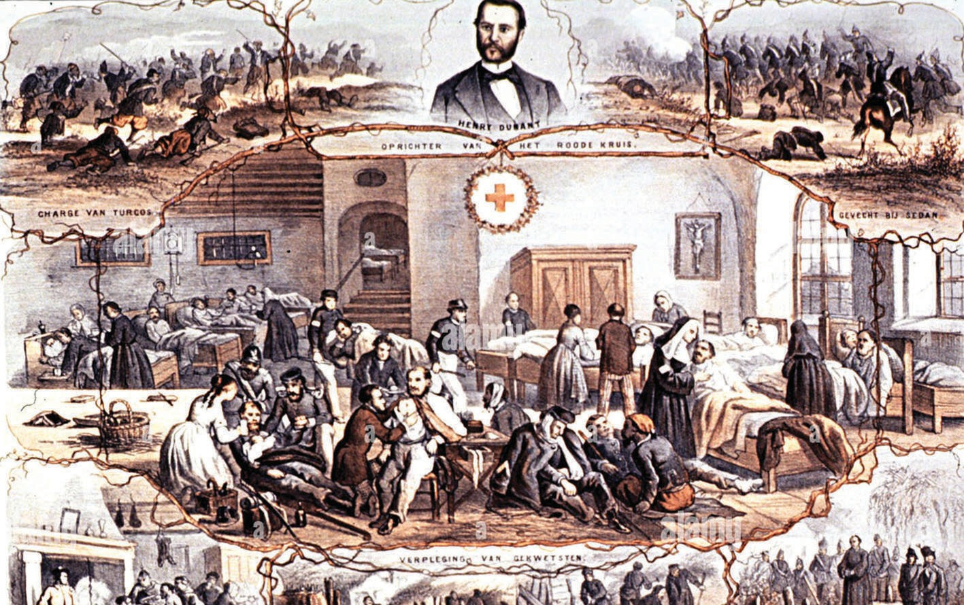

48 Chapter 3: War and Medicine Chapter 3: War and Medicine 49

of malaria, and it was widely used from the late 19th century. In 1899, Manson found the London School of Tropical Medicine, which trained practitioners to be sent to tropical colonies to provide medical services. The British government also set up the Tropical Diseases Research Fund in 1910 to support research on tropical diseases. While it did not eradicate the disease, it allowed the Europeans to penetrate the hinterland of Africa and Southeast Asia and deploy a stronger military presence in the tropical colonies at a lower cost.

▲ Figure 3.2: Entrance sign and logo - London School of Hygiene and Tropical Medicine; note the mosquito and insects as decorations. (© User:Colin / Wikimedia Commons)

Another major problem faced by the colonial militaries was venereal disease, also known as Sexually Transmitted Diseases (STDs). STDs are threats of colonial garrisons as it gradually sapped the effectiveness of the soldiers and added much cost to maintain a garrison in far flung colonies. However, the 19th century morality and attitude towards sex and sexuality also prevented those who were in charge to realize the causes of the problem, and decision makers blamed the soldiers and more usually the sex workers. The issue of STDs was often seen as a shameful issue among the servicemen, which added difficulties in dealing with it. This led to the introduction of often inhumane treatment of sex workers, most of them were the locals, by the colonial medical authority. For example, under the Contagious Disease Act, prostitutes were registered and those who were found infected with STDs would be locked up in infectious diseases hospitals and be examined by male practitioners until they were cured or deceased. Such arrangement, however, was strongly criticized by feminist and other concerned groups in the United Kingdom and was later partially abolished. It was not until the mid-20 century that the
widespread use of condoms prevented STDs from being a major problem in armed forces.

Changes in the First World War
During the First World War, armies that participated in the war were equipped with weapons that reached a high level of proficiency such as machine gun and rapid-firing field artillery. The increased volume of firepower on the battlefield led to much higher rate of casualties and new types of physical and psychological wounds that cannot be treated with old methods. Some illnesses, such as psychological damage, were also poorly understood at that time. While the war killed millions and wounded many more, it also led to advancement in medical science and care that provided experience for future generations.

The war witnessed a number of technological and organizational changes that led to a revolutionary improvement in battlefield medical care and surgical methods. At least in the more advanced armies such as the British Army, wounded soldiers would receive treatment in stages at regimental aid post, casualty clearing station, and base hospital. Novel first aid materials such as Kleenex were used to prevent bacterial infection. They would be carried by dedicated teams of stretcher- bearers, motor ambulances, and hospital trains. Antiseptic and anesthesia would be used to prevent infections and ease their pain. Unnecessary amputation can also be avoided because of the introduction of new methods such as Thomas splintiv. Effective blood transfusion and better knowledge of blood type also allowed soldiers to enjoy a higher chance of survival. Some ambulances were equipped with X-ray machines to detect shrapnel and bullets, in the body of the wounded.

Other life-saving developments were introduced in the field of medicine, such as the widespread use of vaccination and pills. Before the age of the vaccination, diseases like gangrene and typhus had been fatal on the battlefield. In 1914, the French government implemented a compulsory typhoid vaccination schemes for the recruits of the French Army. In a later stage of the war, gelatin pills were introduced to stem diseases such as “trench fever”, a typical disease to soldiers operating in crowded and dirty trenches.

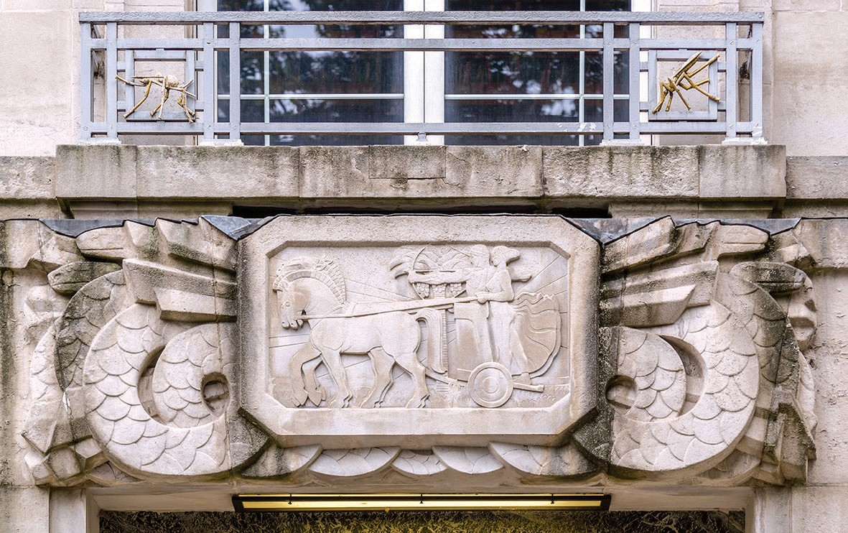
50 Chapter 3: War and Medicine Chapter 3: War and Medicine 51

Advancement in plastic surgery also helped soldiers who were disfigured by shrapnel and bullets, a more common occurrence because of not only the prevalence of these weapons but also the higher chance of survival of the soldiers because of improved medical care. More advanced surgery skills enabled the wounded soldiers to receive better suturing to avoid large scars. For the more serious cases, reconstructive surgeries were introduced to help the affected. France was the first country adopting skin and bone grafts to repair the injured faces to the soldiers. With the up-to-date prosthetic devices such as mouth openers and Darcissac helmets, it was possible to restore at least part of the facial functions. Prosthetic limbs are also introduced to help those who were amputated.

▲ Figure 3.3: British field ambulance during the First World War as shown in Illustrated London News, 1915. (https://www.nationalarchives.gov.
uk/wp-content/uploads/2018/11/ZPER-34-147_01- ambulance-transport.jpg)
▲ Figure 3.4: Use of X-Ray to find bullets during the First World War as shown in Illustrated London News, 1915. (https://www.nationalarchives.gov. uk/wp-content/uploads/2018/11/ZPER-34-146_45- devs.-in-X-rays.jpg)

▲ Figure 3.6: A charcoal drawing in 1916, showing women manu- facturing prosthetic limbs. (World War I: women manufacturing prosthetic limbs. Charcoal drawing with bodycolour by A. Garratt, 1916. Wellcome Collection. In copyright)

▲ Figure 3.5: Blood transfusion apparatus used in the period 1914-1918. (Credit: Blood transfusion apparatus, United Kingdom, 1914-1918. Science Museum, London. Attribution 4.0 International (CC BY 4.0))
Another landmark advancement in medical science during the war was a better understanding of the psychological damage on soldiers and the ways to deal with such damage. During the war, many soldiers underwent mental collapses and breakdowns, caused by a variety of reasons from poor living environments, continuous stress, and intense bombardments. Mental illness was initially coined “shell shock” and poorly understood. Soldiers suffered from shell shock would show different symptoms and act abnormally, but they were sometimes seen as faking illness or even punished (sometimes shot) for being ill. Gradually, advancements

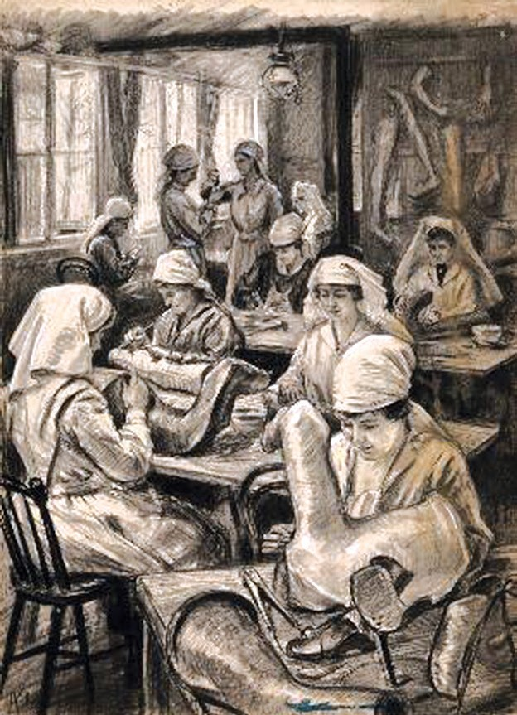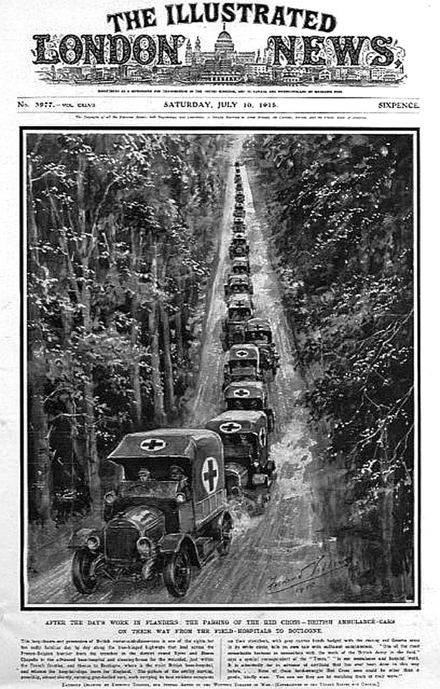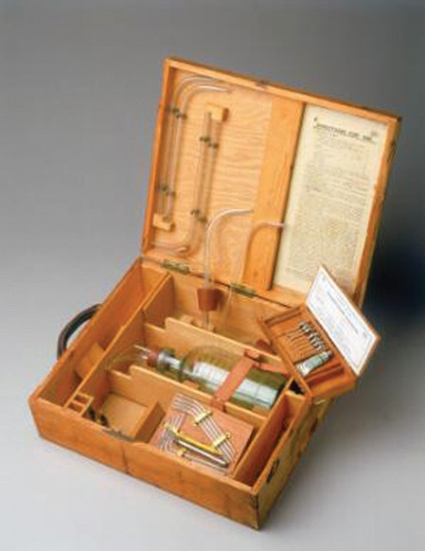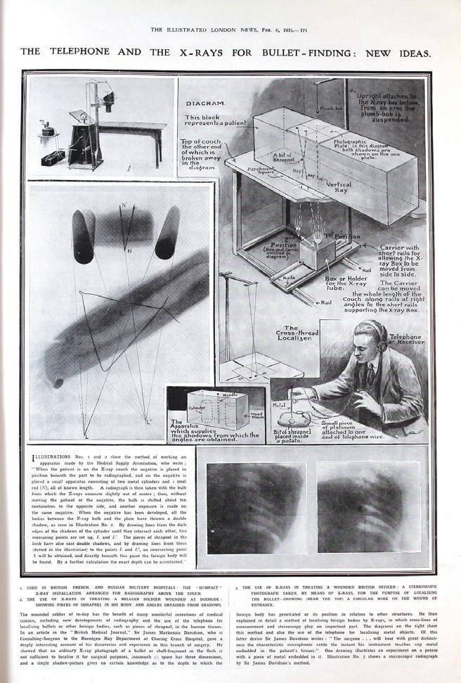
52 Chapter 3: War and Medicine Chapter 3: War and Medicine 53

Front. They provided immediate treatment to the soldiers who suffered from shell shock. Mental treatments for the soldiers continued long after the war, as many showed little or no improvement. In Canada, soldiers who suffered from shell shock and were deemed irrecoverable would remain in hospitals for a long time. While it was still a long way from an adequate understanding on the psychological impact of the War on soldiers and many of the soldiers who suffered from mental damage did not recover, there were at least unprecedented advancements on this dimension during the First World War.
in neuropsychiatry led to a better understanding of shell shock. In 1916, the British
deployed the first group of Consultant Psychologist and Neurologist to the West
The flu, despite its name, was originated from the United State in Spring 1918,
when a large number of US military personnel traveled to Europe. When the flu was
spread to Europe, millions of soldiers and civilians were infected. Governments of the United Kingdom, France, and Germany, busy fighting a war for survival, implemented strict censorship on the news about the outbreak in order to maintain national morale. As Spain was the only major neutral country that was allowed the news to be spread, the pandemic was thus named Spanish flu.

The spread of the deadly flu was attributed mainly to several factors. First, the Spanish Flu was new to the world in 1918. Only until recent years had the scientists discovered the pig and bird gene segment in influenza, which was unknown to the people in the 1910s. Also, given it was a pre-antibioticv era, many of the remedies had yet to be available. Moreover, the public health systems even in the most advanced economies were underdeveloped. After all, the war, on one hand, helped to spread the flu because million soldiers and animals traveled across continents and lived in close quarters, and on the other, prevented governments to concentrate their effort and resources to deal with the outbreak.

▲ Figure 3.7: A watercolour showing a shell-shocked man in a uniform of the British army. (A shell-shocked man in a uniform of the British Army seated on a rock, with a sunset behind, about to kill himself. Watercolour by
M. Bishop, 1973. Wellcome Collection. In copyright)

The Spanish Flu
The end of the First World War was by no means an end of human tragedy. Towards the end of the war, the world suffered from one of the worst influenza pandemics in human history. The Spanish Flu of 1918-1919 led to 500 million infections and possibly killed 50 million people.

▲ Figure 3.8: Emergency hospital during influenza epidemic, Camp Funston, Kansas (1918). (U.S. Army pho- tographer, Public domain, via Wikimedia Commons)

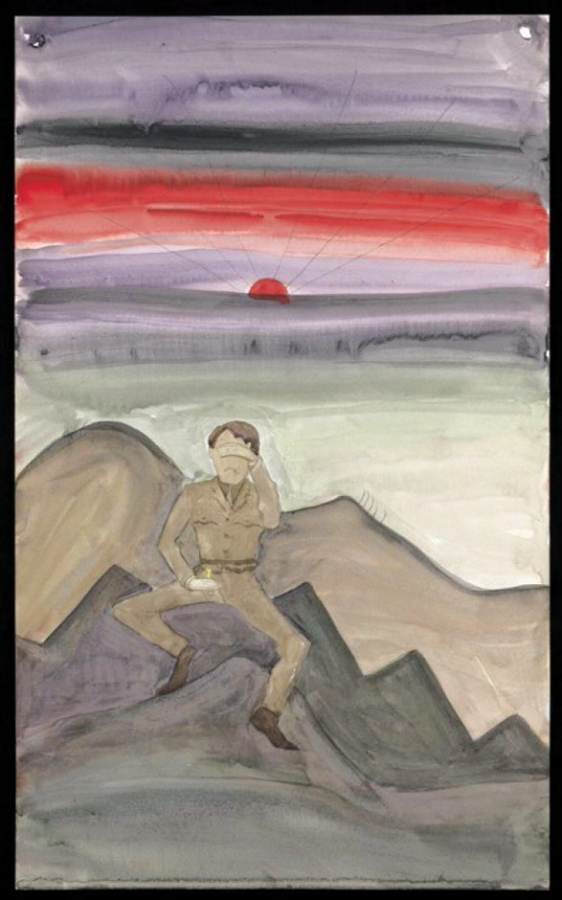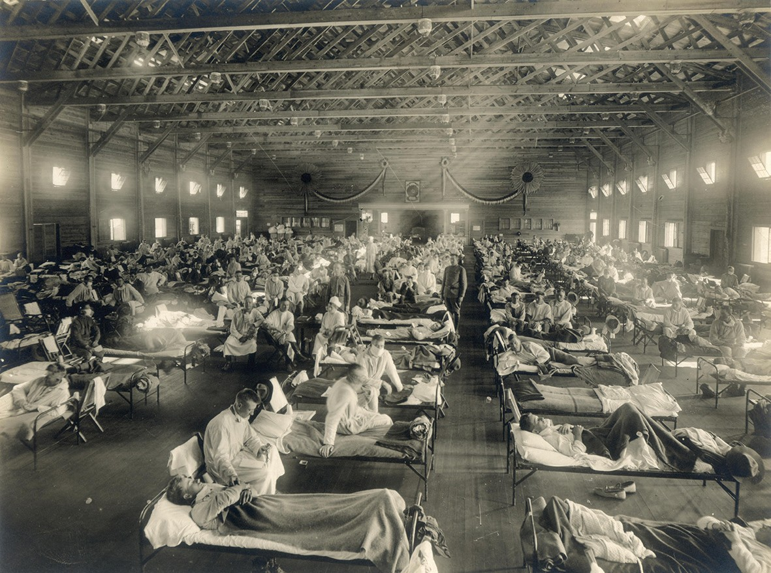
54 Chapter 3: War and Medicine Chapter 3: War and Medicine 55

Unlike many other pandemics, the Spanish Flu was the most lethal to young adults. When the pandemic broke out, the First World War was in its fourth year and the powers had spent an enormous amount of resources, money, and manpower for the war effort. The death of a large number of young adults might have further drained the pool of manpower for all the fighting powers and affected their morale. On the other hand, the influx of hundreds of thousands of fresh American troops tipped the balance between the Central and Entente powers, and ultimately led to the collapse of German resistance.

WWII and Medicine
In less than two decades after the First World War, the world was engulfed by an even larger conflict that witnessed intense fighting not only in Europe, Africa, and the Middle East but also Asia. During the war, most of the key problems of combat medicine were almost solved, thanks to the scientific breakthroughs in recent decades. New tools such as penicillin and sulfanilamide further prevented infections of wounds and the spread of pandemics among the soldiers, preventing another outbreak of influenza such as the Spanish Flu. Soldiers also benefited from advancements such as blood plasma and morphine, which allowed more soldiers to survive from surgeries. Alternatives to existing medicine such as Atabrine as a substitute of Quinine were developed, when the Axis powers controlled the source of Quinine production (the Dutch East Indies).
Perhaps the most important for subsequent decades, the experience of war led to a wave of humanitarian progressivism, which called for a more active government role in taking care of the population and more recognition of patients’ rights. For example, the British government took pains to ensure its population was fed with a healthy and adequate diet despite the disruption of its overseas trade. This led to a better understanding of nutrition science and greater involvement of the government in ensuring the health of the population. The prevalence of such progressivism eventually led to the formation of the National Health Service, the first territory-wide medical care system of the modern world. The war also witnessed the emergence of international professional communities that helped to promote health and to improve medical care around the world. The World Health Organization was the case in point. On the other hand, advancements in medical science during the war also paved the way for the rise of pharmaceutical giants.

Summary
The above paragraphs illustrate how military conflicts affect changes in medical sciences and medical care during the modern times. The return of wounded soldiers to the front line is crucial for a military to sustain its fighting power; on the other hand, the provision of advanced medicine and medical care to combatants is also a sign of modernity and better understanding of humanitarian ideals. Many wartime medical advancements also benefited the post-war world, often in unexpected ways. X-ray machine, ambulance, vaccination, pill, blood transfusion, psychological treatment, and reconstructive surgeries are all common features of modern medical science. International organizations and norms of practices created during wartimes are also in force, to the benefit of the public, although these changes were made with political complications.

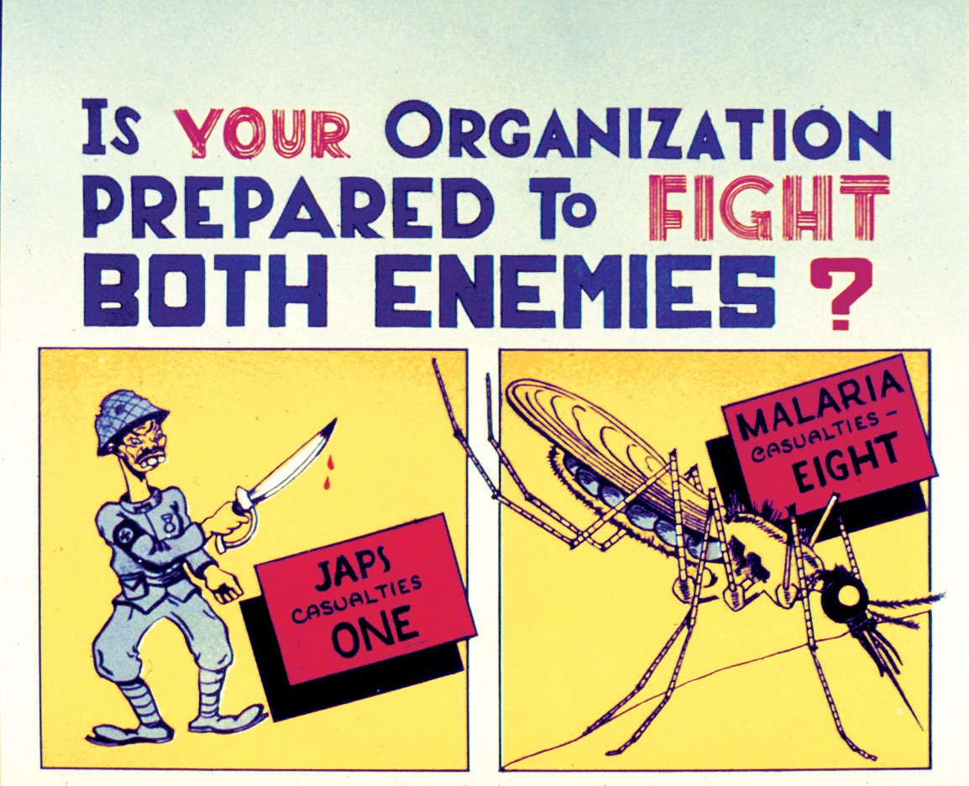

▲ Figure 3.9: Malaria Poster of the US Army during the Second World War. (Images from the History of Medicine (IHM))

56 Chapter 3: War and Medicine Chapter 3: War and Medicine 57

- Florence Nightingale (1820-1910): An English social reformer, statistician and
the founder of modern nursing. Nightingale came to prominence while serving as a manager and trainer of nurses during the Crimean War.
- Henry Dunant (1828-1910): A Swiss humanitarian, businessman, and social activist, the co-founder of the Red Cross.
- Malaria: A mosquito-borne infectious disease that affects humans and other animals. It could be commonly found in tropical and sub-tropical regions.
- Thomas splint: A splinting device that helped support and realign the limb; it enhanced the recovery of the soldiers’ wounded limb again.
- Antibiotic: A type of antimicrobial substance active against bacteria and the most important type of antibacterial agent for fighting bacterial infections.
58 Chapter 3: War and Medicine
Chapter 3: War and Medicine 59

Cooter, Roger; Harrison, Mark and Sturdy, Steve (eds). Medicine and Modern Warfare.
Suggested Readings:
Amsterdam and Atlanta: Rodopi, 1999.

Headrick, Daniel R. The Tools of Empire: Technology and European Imperialism in the Nineteenth Century. New York: Oxford University Press, 1981.
Larner, Melissa, James Peto, Nadine Käthe Monem, Wellcome Collection, Deutsches Hygiene-Museum Dresden, and Wellcome Images. War and Medicine. Wellcome Collection. 2008.
尼爾‧弗格森（著）、區立遠（譯）。《第一次世界大戰，1914-1918 戰爭的悲憐》。台北：廣場出版，2016。
瑪格蕾特．麥克米蘭（著）、曹嬿恆（譯）。《戰爭：暴力、衝突與動盪如何形塑人類與社會》。台北：商周出版，2021。
皮國立。《全球大流感在近代中國的真相：一段抗疫歷史與中西醫學的奮鬥》。台北：時報出版，2022。

Meaning of terms:

Chapter 4
War and Society

Introduction
War has been an integral part of human history. On the one hand, war brought destruction and threatened the life and properties of the people as well as social changes; on the other hand, societies shaped and limited the mode and scale of warfare. This chapter deals with three questions relating to war and society: first, ‘How societies were organized for war?’; Second, ‘Who fought in wars?’; and third, ‘What was the relationship between the military and society?’. The experience and development of the Prussian Army from the 17th to 19th centuries would serve as a case in point.

War and Society from the Early Modern Period to the Enlightenment (late 15th century to late 18th century)
One characteristic of the early history of German militarism, particularly the Prussian militarism, was the close connection between landed aristocracy known as the Junkeri and the army. At the beginning of the Early Modern Period, the German
armies of the time comprised of knights from the Junker class and foot soldiers who came from the peasantry. As the conscription system of feudalistic kingdoms was inefficient, the size of the armies was limited. The size of the German-Prussian armies expanded, however, after the German Peasants’ War (1524-1525), and the Thirty Years’ War (1618-1648), as the scale of war increased. The size of the Prussian Army further expanded during the reign of the ‘Soldier King’ Frederick William I (1688-1740, r. 1713-1740). In order to meet the ever-increasing demand of soldiers, the monarch had to reform the not-so-efficient conscription system. As a result, the Canton System was introduced in Prussia; the country was divided up into districts, and each would contribute the men for a standard formation (a regiment). This required Prussia to expand its capability to extract resources from the districts and build up a more efficient central government to coordinate the war effort.

As soldiering was not a desirable or popular career at that time, armies of the 17-18th centuries comprised mainly of the poor and desperate men. Little could be expected from these people on the battlefield, as they lacked fitness, incentive, and training to fight, and their discipline was poor. In the War of the Austrian Succession (1740-1748), Prussia painfully learned the importance of military discipline. It was
first, the soldiers could fire volleys that could inflict greater damage to the enemy. Secondly, and more importantly, it maintained the cohesion of the units, preventing soldiers from running away. That explained the slowness of the marching speed of the Prussian Army — 75 steps in a minute during the early 18th century. The march was tailor-made for the poorly trained Prussian infantrymen, as it had to make sure that everyone could catch up with the formation. To maintain the formation, the King needed reliable officers. In the case of Prussia, a large proportion of officers came from the Junkers. Thus, despite the differences between the Medieval and Early Modern military systems, the nobility retained their leading position in the European armies.

▲ Figure 4.1: A painting entitled “Hohenfriedeberg - Attack of Prussian Infantry”, showing linear formation, a typical infantry formation of the European during the 18th Century. (Carl Röchling, Public domain, via Wikimedia Commons)
Chapter 4: War and Society
necessary to organize the soldiers in close lines or columns so that they could be
controlled effectively. There were two main advantages of close/dense formations:

The Prussians also relied on cheaper and less sophisticated weapons that emerged in the 18th century to equip and train their soldiers. Early firearms, such as matchlock guns, were complicated and inefficient. To fire a matchlock gun, a soldier had to follow many steps. The flintlock guns that gradually replaced the matchlock in the early 18th century were much easier to use. The rate of fire was further improved with the introduction of smoother barrels and paper cartridge. Furthermore, the introduction of bayonets—a dagger designed to fit on the end of a rifle’s muzzle—allowed the infantrymen to perform the role of musketeer and pikeman simultaneously. While the above changes allowed the Prussian army to stand and fight, the offensive capability of this army was still limited because of the quality of its soldiers. This was solved by Frederick the Great (1712-1786),

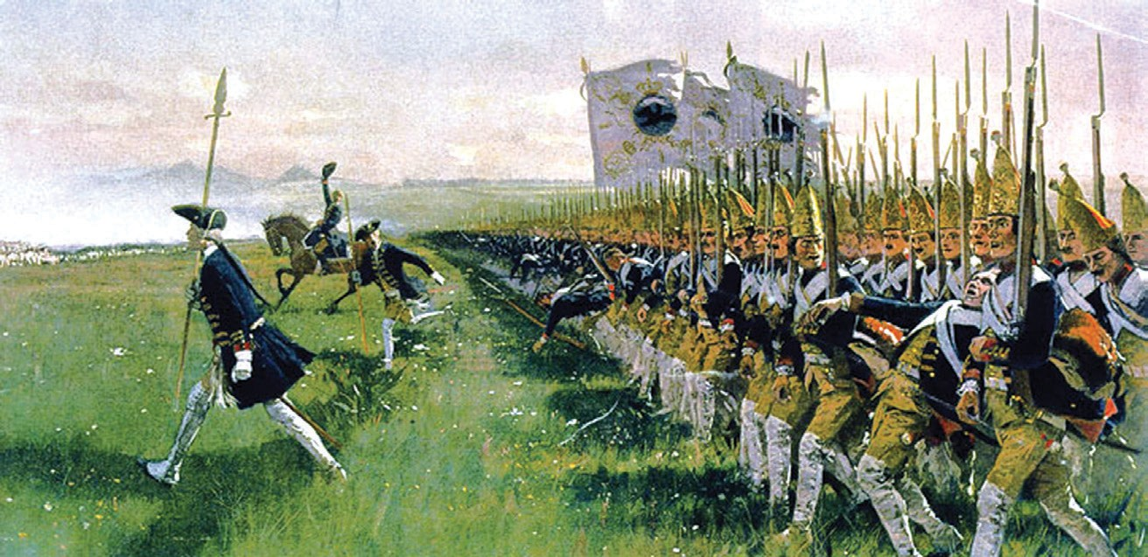 62 Chapter 4: War and Society Chapter 4: War and Society 63

Army to execute more complicated tactical moves such as the ‘oblique order,’ which required the formations to march and deploy in good order. All these innovations in weaponry, backed by improved training and tactics, transformed the Prussian Army into an efficient fighting force compared to other European armies. Most important, the abovementioned developments led to the gradual emergence of a ‘standing’ army that consisted of professional soldiers and officers, rather than soldiers who joined the army out of desperation or poverty.
who introduced intensive military training and innovative tactics to improve the
capability of the Prussian Army. Intensive drilling finally allowed the Prussian
army set the tone of modern armed forces. First of all, it expanded exponentially in
terms of size compared to the dynastic armies such as the Prussian Army. As soon
as the French Republic was established, France implemented the policy of levee en masse — practically universal conscription, which allowed France to build an army of unprecedented size. Secondly, as the Republic abolished the nobility, the domination of the nobility in the officer corps quickly declined. During the Revolution, numerous generals and numerous officers who came from the noble class were executed. Thereafter, meritocracy was introduced, as Napoleon allegedly said: ‘every French soldier carries a marshal’s baton in his knapsack.’ Thirdly, galvanized by nationalism and revolutionary fervor, soldiers of the French army were much more enthusiastic compared to their European counterparts. Furthermore, the War of American Independence (1775-1783) also inspired the French. During the war, the Americans, knowing that they were no match against the well-trained British Army in the field, abandoned the formations favored by European armies and formed skirmish lines instead. The use of skirmishers proved effective, as the Americans eventually defeated the British. Shocked by the effects of skirmishers, European nations gradually established their skirmish forces for the tasks of harassing the enemy, and France was one of the first nations which adopted it successfully, partly because of the better quality of its soldiers.

▲ Figure 4.2: ‘Portrait of Frederick the Great’ in 1870.

▲ Figure 4.2: ‘Portrait of Frederick the Great’ in 1870.

The Prussian Army, led by Frederick the Great, enjoyed a distinct advantage in Europe during the second half of the 18th Century. Its leading position did not persist, however, as a new form of social-military relations emerged as a result of the French Revolution, and the Prussian Army was repeatedly defeated during the Revolutionary Wars and Napoleonic Wars until it also learned from the latest changes.

Impact of the French Revolution
The French Revolution brought not only political changes but also immense changes in civil-military relations. Several features of the French revolutionary

▲ Figure 4.3: A painting in 1808 entitled “Les conscrits de 1807 défilant devant la porte Saint-Denis” (Departure of conscription in 1807). French conscripts heading to the barracks; the picture shows the passion shown by the public as well as the grief shown by the families of the conscripts. (CC0 Paris Musées / Musée Carnavalet - Histoire de Paris)

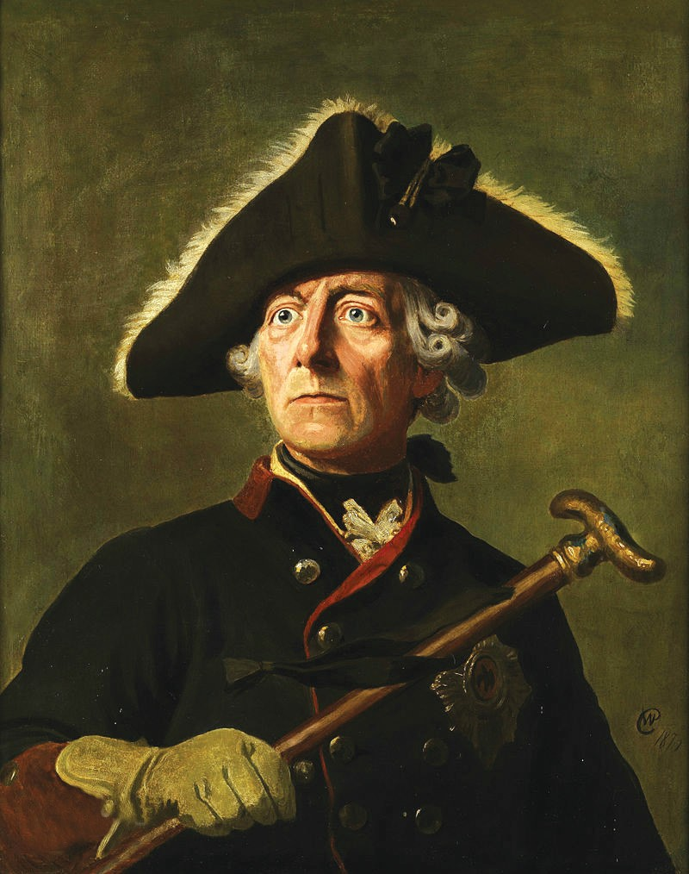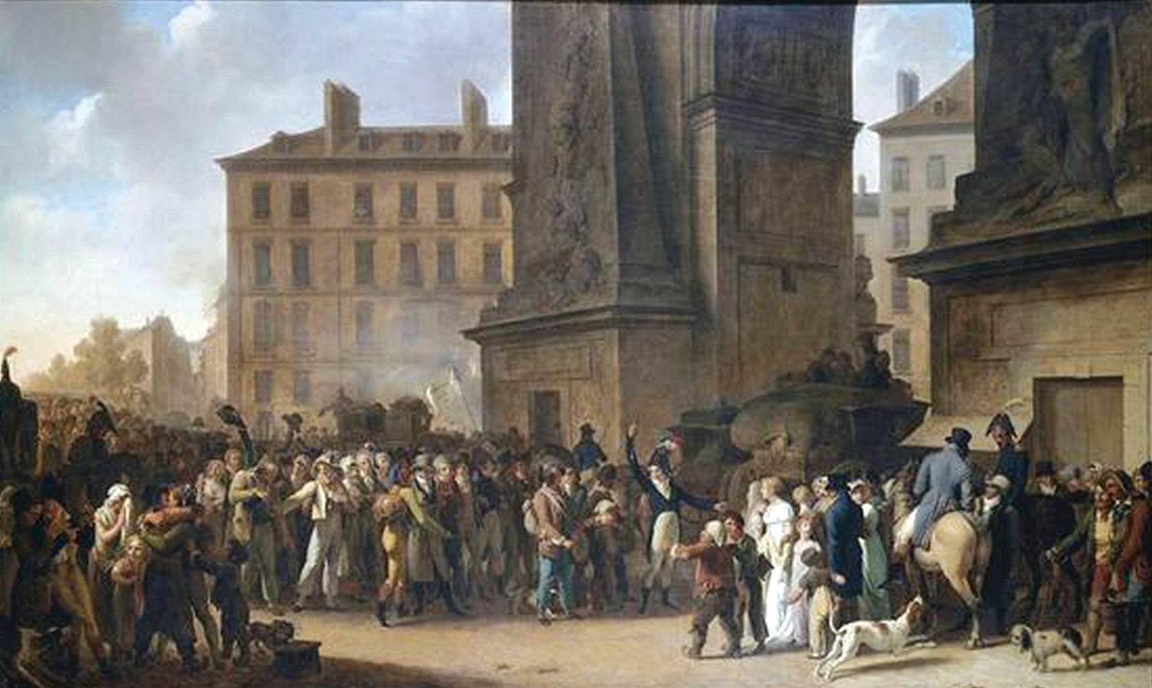
64 Chapter 4: War and Society Chapter 4: War and Society 65

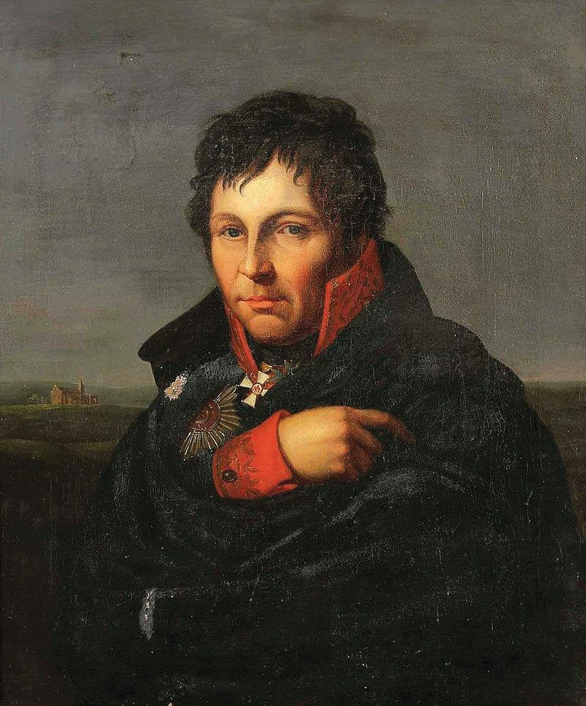In contrast, the Prussian army started to lag behind its time. While the French opened up ladders of advancement for the talented officers, two-thirds of the Prussian officers were still Junkers, and 79 out of the 142 generals were men above
60. The strength of the Prussian army was, understandably, in decline. During the Battle of Valmy (1792), the Prussians first tasted the vigor of the revolutionary army. Throughout the battle, the high-spirited French tenaciously held their position despite the barrages from the Austrian and Prussian artillery. In the end, knowing that their enemy remained unshaken, the Austro-Prussian army withdrew. The performance of the French illustrated the strength of a national army. However, the Prussian Army missed the chance to adapt and reform because of the partition of Poland soon distracted Prussia.

Despite its conservative outlook, however, the Prussian Army was also capable of reform. Two of the pioneers were Georg von Berenhorst (1733-1814) and Dietrich von Bulow (1757-1807). Influenced by humanitarianism, Berenhorst attempted to improve the living standard of ordinary soldiers, while Bulow, fascinated with scientific ideas, advocated tactical reform according to scientific principles. The most important Prussian military reformers were Gerhard von Scharnhorst (1755- 1813) and August von Gneisenau (1760-1831). Born in a Hanoverian peasant family, Scharnhorst received his education in the military academy and joined the Prussian army in 1801. His background might have contributed to his reformist character, but his experience during the Napoleonic Wars was perhaps more important. Scharnhorst witnessed the might of the French army in the Battle of Jena–Auerstedt (1806), during which the Prussians were resoundingly defeated, and Scharnhorst himself was taken as prisoner of war. Right after his release, Scharnhorst was appointed the head of a reform committee and oversaw the reform with his comrade Gneisenau.

▲ Figure 4.4: Portrait of General Gerhard von Scharn- horst. (Friedrich Bury, Public domain, via Wikimedia Commons)

The committee compiled 606 volumes of reports in order to evaluate the performance of the Prussian Army during the Napoleonic Wars. The reform was based on the French model, with the key feature being the introduction of mass conscription. A General Staff comprised 31 members was formed, overseeing all military planning and decision making. A war college was established in 1810 in Berlin. The welfare of the soldiers also improved; for example, capital punishment was abolished. In 1813, Prussia introduced a mass conscription system to replace the Canton system. A militia force, known as the Landwehr, was formed; qualified men between the age of 18 and 45 were called up to serve. The conscription system allowed Prussia to raise a sizable army to fight against Napoleon during the final years of the Napoleonic Wars. However, the conscription system did not survive after the end of the Napoleonic Wars in face of the Prussian government that was more interested in political stability.

The impact of the French Revolution and the Napoleonic Wars was not limited to the military sphere. European societies also underwent a process of militarization. During this period, European states portrayed sacrificing for the nation as an honor. Popular portrayals of the Battle of Valmy depicted how French soldiers fought against the Austro-Prussian armies while singing the “La Marseillaise”, the song that became the national anthem of France. While to what extent revolutionary

66 Chapter 4: War and Society Chapter 4: War and Society 67

fervor helped the French to overcome the dynastic armies of the European monarchs was debatable, nationalism quickly spread to the European countries, especially those submitted to Napoleon. People of these nations stood up and revolted against the French occupiers. Among these struggles, the war in Spain was particularly brutal. During the Peninsular War (1807-1814), the Spaniards fought a guerrilla war against the French occupying army that consumed much energy of the French Empire. Eventually, with the aid of the British forces led by the Duke of Wellington (Arthur Wellesley, 1st Duke of Wellington, 1769-1852), the Spaniards drove the French out of their country.

As nationalism prevailed, the cult of national war heroes also emerged. Ferdinand von Schill (1776-1809), a Prussian Major who staged an unsuccessful revolt against the French occupying forces in Germany and died in 1809, became the national hero of Prussia and later of Germany. As soon as 1830, his patriotic tales had already been widely disseminated in Germany; plazas and streets were named after him, and statues of him were erected. Almost every state created a similar hero. For example, Admiral Horatio Nelson (1758-1805), who defeated the Franco-Spanish fleet during the Battle of Trafalgar (1805)ii, has become the British national hero until today. His statue is still standing in the heart of London, at Trafalgar Square.

Changes in the 19th century
After the defeat of Napoleon in the Battle of Waterloo (1815)iii, no major wars were fought between European countries for decades until the Crimean War (1854-1856). The international order was maintained by the Concert of Europe, as states became more willing to solve their problems through negotiations. Military conflicts, if inevitable, were only of limited in scale and nature. However, technological changes brought by the Industrial Revolution, the spread of nationalism, and the competition between the powers made changes in civil-military relations inevitable. In particular, the emergence of communication technologies such as railway and telegraphy allowed the states to better control their territories and resources. From the late 1850s, Prussia underwent another military reform that had much impact on society under Albrecht von Roon (1803-1879)iv. Built on the Landwehr system introduced during the Napoleonic Wars, Prussia increased the number of men being conscripted. According to plan, Prussia would be able to maintain an army of 189,000 regular soldiers (63,000 soldiers conscripted each year serving for three years), 316,000 Reserves, and 252,000 Landwehr soldiers, comprising a national army of three quarters of a million. Before the Industrial Revolution, it would be impossible for a nation to mobilize, provision, and equip
so many men in short notice. During the Franco-Prussian War (1870-1871), Prussia sent 450,000 troops to the frontier within a month. The ability to mobilize more men allowed the Prussians to enjoy a comfortable numerical superiority that was crucial for their victory over the French.
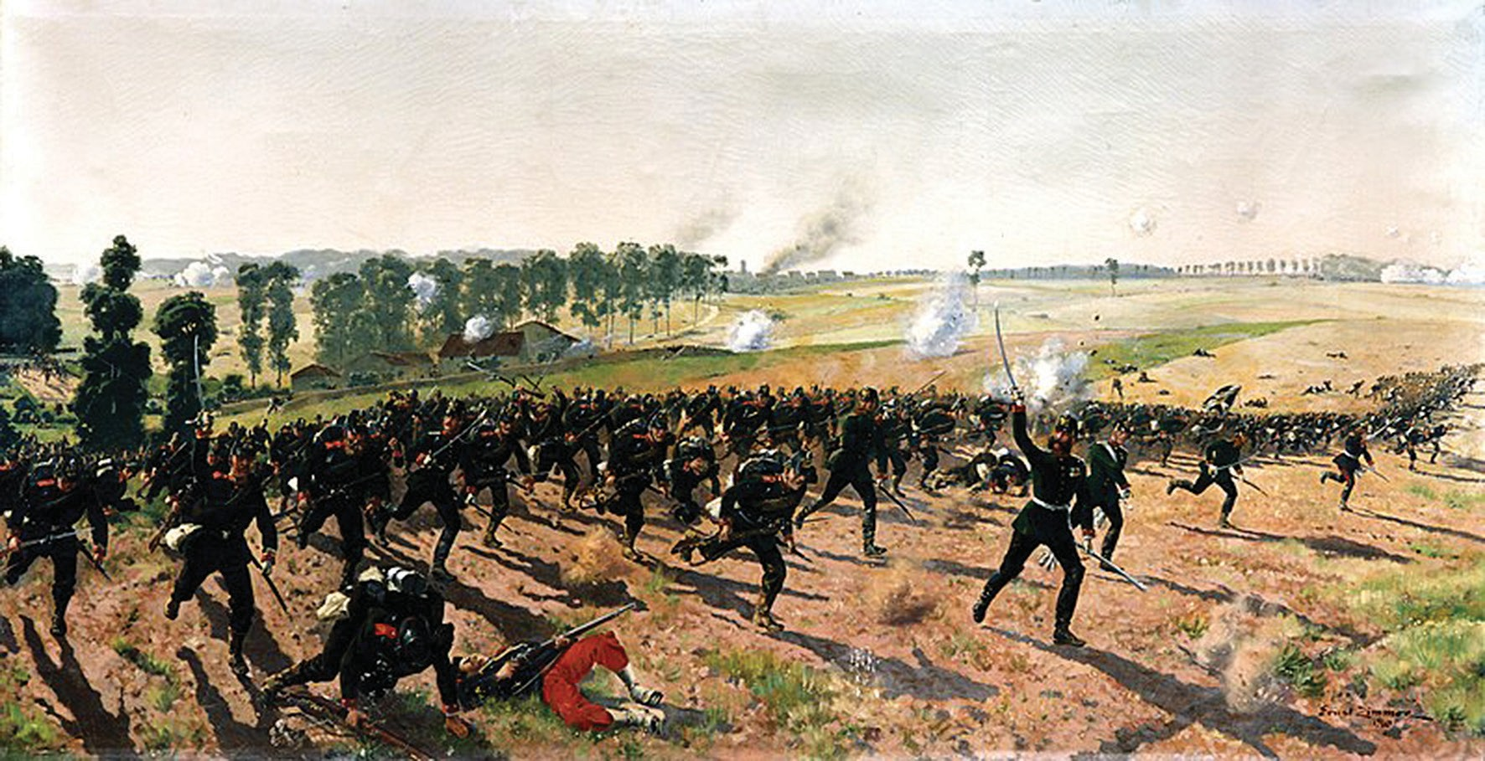
▲ Figure 4.5: A painting entitled “Das Lauenburgische Jäger-Bataillon Nr. 9 bei Gravelotte” (The “Rifle Bat- talion 9 from Lauenburg” at Gravelotte), showing Prussian army during the Franco-Prussian War. (Ernst Zimmer (1864-1924), Public domain, via Wikimedia Commons)

Prussia’s swift victory over Austria and France shook Europe and the world, and the Prussian model was widely emulated. France, for instance, established a General Staff in 1871 and introduced universal conscription in 1872. Qualified French men above the age of 20 would be selected by ballot to serve in the army for two years. After that, he would be placed in reserve, to be called up if needed. Russia also introduced a conscription system in 1874; in theory, all men over 20 had to serve in the army for six years and nine years as a reservist. The only major European power that had not introduced a conscription system was Britain, which could rely on the large pool of manpower from India and other colonies. Before the First World War, every German man theoretically had to serve in the army in one way or another from the age of 20 to 45. He would first serve in the army for two years (three years for artillery and cavalry) and then join the Reserves for five years (four for artillery and cavalry). He would then serve in the Landwehr for another 11 years, and finally in the Landsturm (the reserves of the Landwehr) for seven years.

During the 19th Century, as a result of the introduction of universal conscription in many counties, armed forces were seen as ‘School for the nation,’ as people from different parts of the country, despite their social, cultural, and ethnic background,

68 Chapter 4: War and Society Chapter 4: War and Society 69

were trained not only as a soldier but also a citizen. After the unification, the German Empire introduced universal conscription throughout the country, although some of the Germanic kingdoms were allowed to keep their armies. The system was also introduced to Japan and the South American countries. However, the impact of military service on introducing a national culture was less direct, as nations without universal conscription (such as the United Kingdom) also developed a strong identity. On the other hand, the conscription system did not bring unity to the Hapsburg Empire. In some countries, military service was also seen as a prerequisite for political participation. In 1901, Sweden introduced universal conscription; eight years later, those who served in the armed forces and paid tax were allowed to vote for their political representatives in the Riksdag (Parliament). During the last decades of the 19th Century, the army and navy became symbols of power and unity in many European nations. Through the emerging mass media, popular militarism also took root. Young boys would play with toy soldiers and warships; sports were seen as a means to strengthen the people’s mind and body so that they could become better soldiers.

Thus, during the second half of the 19th century, the size of armed forces and the military expenditure of major European nations expanded rapidly. Ever- expanding armies and ever-higher military expenditure, ironically, did not give Europeans a sense of security. Helmuth von Moltke the Younger (1848-1916)v, the Chief of the Great German General Staff, for instance, contemplated a preventive war when he saw Russian’s military expenditure increased. Before the First World War, Jan Bloch (1836-1902), a Polish banker who wrote extensively about future warfare, suggested that if the industrial powers fought against each other, modern firepower would soon turn the battle into a seemingly fruitless war of attrition. The war would become a contest of economic power, and the powers would eventually be consumed by internal strife because the people would refuse to fight and stage a revolution. His predictions, however, were largely ignored by the contemporaries.

The First World War and Beyond
As expected, the First World War also brought some changes in civil- military relations. First, the state gradually extended its control over different aspects of the lives of the people. In Germany, the Supreme Army Command became increasingly powerful in economic planning, and its leaders effectively became the dictator of the country during the war. In 1916, the Supreme Army Command launched the Hindenburg Program to boost the war economy through central planning. However, the military officers failed to win the support of the industrialists and the labor, and in the face of trade blockade, the German economy
gradually collapsed during the war. In other countries, the government also formed specialized departments and committees to steer the war economy. In the United Kingdom, the British formed the Ministry of Munitions in 1915, staffed by civilian officials and representatives from the businesses. During the war, states devised elaborate propaganda campaigns to persuade the people to continue to support the war effort. As many men had to leave their peacetime posts to fight, many women could find employments that were previously unavailable. The sacrifices of the people during the war partly led to subsequent drives towards universal suffrages for men and women in countries such as the United States and Britain. After the war, the idea of ‘total war’ gradually emerged in European countries and Japan. Some military and civilian thinkers believed that states should be empowered to be able to control, coordinate, and collect all manpower and resources of the society so that they could sustain a prolonged war in the future. In 1936, General Erich Ludendorff vi, a German general who played a leading role in the Imperial German government during the First World War, published the book Der Totale Krieg (The Total War), which argued for the need of an all-powerful state and commander (essentially a dictator) to lead a country at war. However, the book did not address the reason for the failure of the Supreme Army Command that supposedly obtained unchallenged power in Germany during the First World War.

▲ Figure 4.6: First World War British recruitment poster. It shows the transformation of citiznes from all walks of life into soldiers. (© IWM Art.IWM PST 0318)

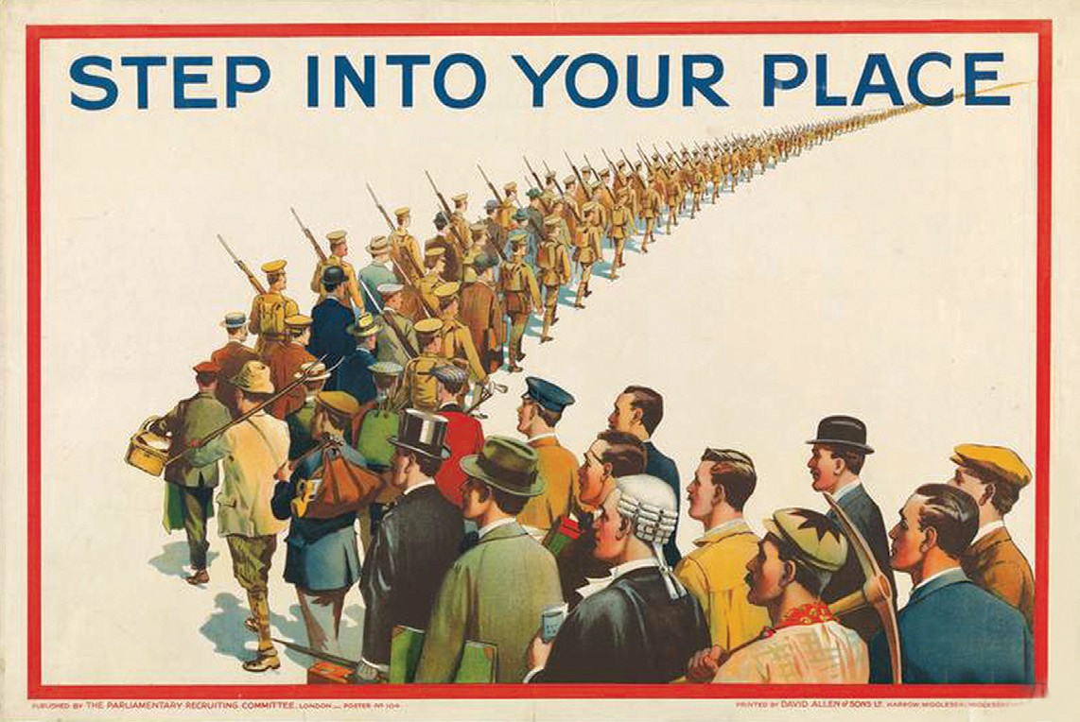
70 Chapter 4: War and Society Chapter 4: War and Society 71

Summary
To conclude, during the modern times, the military was an inseparable part of state and nation-building. As a result of technological changes and pressure of great power competition, nations gradually built up a state that was able to efficiently mobilize the manpower, wealth, and resources of the society for war. After the French Revolution, nation-states built up national armed forces based on universal conscription systems. Although their effectiveness was in question, many saw the military as a means not only to produce soldiers but also ‘modern citizens’. The combination of industrialization and the emergence of mass-conscripted armies, however, did not make the world a safer place. During the First World War, countries that participated in the war expanded their capability in controlling the national economy and launched sustained propaganda campaigns to maintain national morale. Inadvertently, perhaps, the war also allowed women to play a more significant role in economy and society, paving the way for the subsequent political empowerment of women in some of the industrialized countries that had fought the war.

Suggested Readings:
Black, Jeremy. War and the World: Military Power and the Fate of Continents 1450-2000.
New Haven, Conn.: Yale University Press, 1998.

Bond, Brian. War and Society in Europe, 1870-1970. War and European Society. Montreal: McGill-Queen’s University Press, 1998.
English, Allan. Changing Face of War: Learning from History. Montréal: McGill-Queen’s University Press, 2014.
Jones, Archer. The Art of War in the Western World. Urbana: University of Illinois Press, 2001.

Paris, Michael. Warrior Nation: Images of War in British Popular Culture, 1850-2000.
London: Reaktion, 2010.

Scott, Samuel. The Response of the Royal Army to the French Revolution: the Role and Development of the Line Army, 1787-93. Oxford: Oxford University Press, 1978.
尼爾‧弗格森（著）、區立遠（譯）。《第一次世界大戰，1914-1918 戰爭的悲憐》
。台北：廣場出版，2016。
瑪格蕾特．麥克米蘭（著）、曹嬿恆（譯）。《戰爭：暴力、衝突與動盪如何形塑人類與社會》。台北：商周出版，2021。

理查‧奧弗裡（著）。《牛津二戰史》。北京：新華出版社，2018。

Meaning of terms:
- Junker: The landed nobility in Prussia who owned great estates and peasants and dominated Prussia and later Imperial Germany’s military, politics and diplomacy.
- Battle of Trafalgar (1805): A decisive naval battle of the Napoleonic Wars during which the British Royal Navy, led by Admiral Horatio Nelson, defeated the Franco-Spanish fleet. The battle allowed Britain to control the European waters throughout the war.
- Battle of Waterloo (1815): The last battle of the Napoleonic Wars in which the army of the British-led coalition, under the command of the Duke of Wellington, defeated Napoleon’s army. This battle marked the end of the Napoleonic Wars.
- Albrecht von Roon (1803-1879): A Prussian soldier and statesman. He played a role in Prussia’s defeat of Denmark, Austria and France and the unification of Germany.
- Helmuth von Moltke the Younger (1848-1916): German general and the Chief of the Great German General Staff from 1906-1914. He devised war plan and played an active role in the German entry into the First World War.
- Erich Ludendorff (1865-1937): A German general during the First World War; he was responsible for managing the wartime economy of Germany from 1916 to the end of the war. He emerged as a leading figure in the nation’s right-wing fringe after the war and supported Adolf Hitler.

72 Chapter 4: War and Society Chapter 4: War and Society 73

Chapter 5
War and Technological Innovations

War and Technological Innovations

Introduction
In Technology and War, historian Martin van Creveld (1946-) wrote: “War is completely permeated by technology and governed by it.” Although the statement risks exaggerating the importance of technology in wars, it is undeniable that war- fare has been profoundly shaped by technology in human history.

This paper inspects the relationship between warfare and technological inno- vations over three periods: the early modern period, the 19th century, and the two World Wars. First, it is necessary to elucidate the conceptual relationship between the two. The impact of technology on warfare is conspicuous. The discovery of gunpowder ended the multi-millennial-long era of cold-steel weapons; the inven- tion of the steamship and ironclad ended the dominance of wooden sailing ships; the emergence of atomic bombs brought us to the nuclear era and shaped today’s international relations. However, we should not overlook the fact that wars also brought about technological development. Had it not for wars, cannon, steam war- ships, and the atomic bomb would not appear. The emergence of new weapons in history highlights the fact that warfare is a driving force behind technological change. New inventions also lead to its counters and more innovations. In the face of a new weapon, people always try to improve it or create its counter. For exam- ple, the invention of tanks gave rise to a variety of anti-tank weapons; similarly, the emergence of combat aircraft stimulated the development of anti-aircraft weapons and radar.

However, we should not regard technology as the sole factor for changes in the way of fighting. Training, tactical and operational doctrine, strategy, organization, intelligence, combat environment and terrain, political context, and chance, as well as circumstances, all affected the outcome of a war and how people fight. Thus, technology is only one of the many deciding factors, and technological superiority alone cannot win wars. During the Vietnam War (1954-1975), despite having su- perior technology and equipment, the American forces were eventually forced to withdraw. This example serves as a reminder of the danger of overlooking other factors and being obsessive with technology.
The use of gunpowder is undoubtedly one of the most far-reaching innovations in military technology. The emergence of gunpowder weapons indicates the transi- tion of Europe from the medieval to the early modern period. The Chinese had used gunpowder back in the 9th century and have been applying it in warfare since the Song Dynasty (960–1279); the Europeans have been using cannons since the 14th century, if not earlier. Why, then, did the widespread use of gunpowder weapons emerge only in the 15th-16th centuries?

The main reason is that Europe experienced the “Military Revolution” during the period. The theory of Military Revolution was first proposed by Michael Rob- ert (1908-1996)i in 1955 and has been refined by many such as Geoffrey Parker, who contends that the Military Revolution of Europe started in 1494 when Charles VIII (1470-1498, r. 1483-1498) of France invaded Italy with his new siege guns. The new siege guns were distinct and powerful in the way that their mobility was remarkably enhanced compared to their predecessors because of the introduction of wheeled gun carriages, which allowed them to keep up the movement of the army. With the aid of mobile artillery, the French King captured several castles and strongholds that were regarded as impregnable at the time, with relative ease. Although he was eventually defeated, Charles VIII swept across the peninsula and started a series of wars that were later known as the Italian Wars (1494-1559).
Chapter 5:
Early Modern Period: The Military Revolution

The technological superiority of Charles VIII did not persist, as the Italian military engineers quickly developed a new design of fortification that can resist artillery— Trace Italienne (Italian Fort)ii, or the bastion fort. The new design for- sook the tall but thin walls of the medieval castle and replaced them with low and thick sloped walls, which were practically immune to cannonballs. Moreover, an- gled bastions that could cover the dead-zones right beneath the walls protected the corners of the forts. Subsequently, siege warfare became as lengthy and time-con- suming as in the Medieval times.

76 Chapter 5: War and Technological Innovations Chapter 5: War and Technological Innovations 77

▲ Figure 5.1: Map of Palmanova in 1593, showing a typical Trance Italienne. (Special Collections Toronto Public Library from Toronto, Canada, CC BY-SA 2.0, via Wikimedia Commons)
▲ Figure 5.2: A typical Spanish formation during the Thirty Years’ War. (Unknown author, Public domain, via Wikimedia Commons)

In the meantime, there were also changes in weapons and tactics for the infantry, the most significant change being the introduction of firearms in European armies. The 16th-century muskets, however, had a very slow rate of fire and were inaccurate, preventing their effective use on the battlefield by individuals. These obstacles were partly tackled in the 1590s when the Dutch army adopted the volley tactics by Maurice, Prince of Orange (1567-1625). He devised a new drill that allowed the musketeers to deliver a near-continuous fire by organized them into rows that fired and reloaded their weapons alternatively. During the Thirty Years’ War (1618-1648), Gustav Adolf (1594-1632, r.1611-1632), King of Sweden, further improved the tactics. Since then, the number of soldiers using cold-steel weapons declined, giving way to soldiers bearing firearms. Deeper formations were also replaced by formations with fewer ranks and a broader front so that firepower could be more effectively deployed.
Mobile guns, Trace Italienne, and changes in infantry tactics revolutionized European warfare. However, the impact of gunpowder did not stop here. Building bastion forts and forging guns required a vast amount of money. At the same time, the introduction of firearms reduced the cost and training required for individual soldiers, leading to an expansion of the size of armies in Europe. European monarchs had to reform their political and fiscal institutions, asserting greater control over their countries’ resources, in order to collect more tax, manpower, and other resources with greater efficiency so that their country could pay for the increasingly expensive armed forces.

Consequently, due to the widespread use of gunpowder weapons, European kingdoms were able to subdue the nobility as the feudal lords could not afford gunpowder armies and Trace Italienne. This led to the transformation of feudalistic kingdoms into early modern centralized states. While the changes were gradual and often not clear cut, this case shows that the impact of military technology could go beyond the battlefield and permeate into political structure and society.

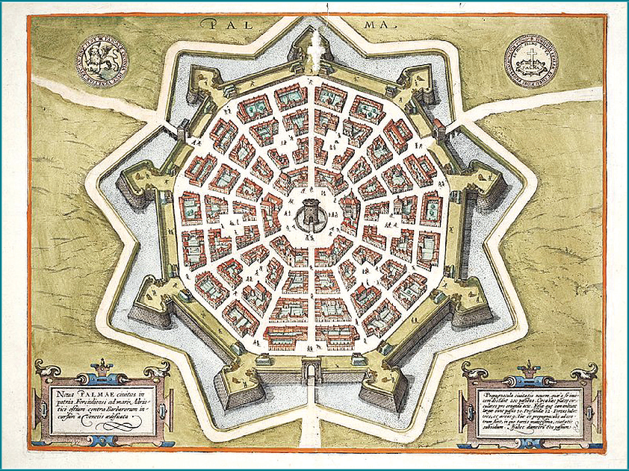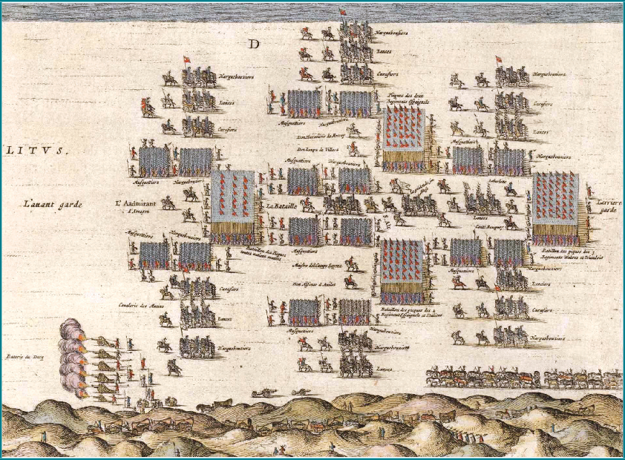

78 Chapter 5: War and Technological Innovations Chapter 5: War and Technological Innovations 79

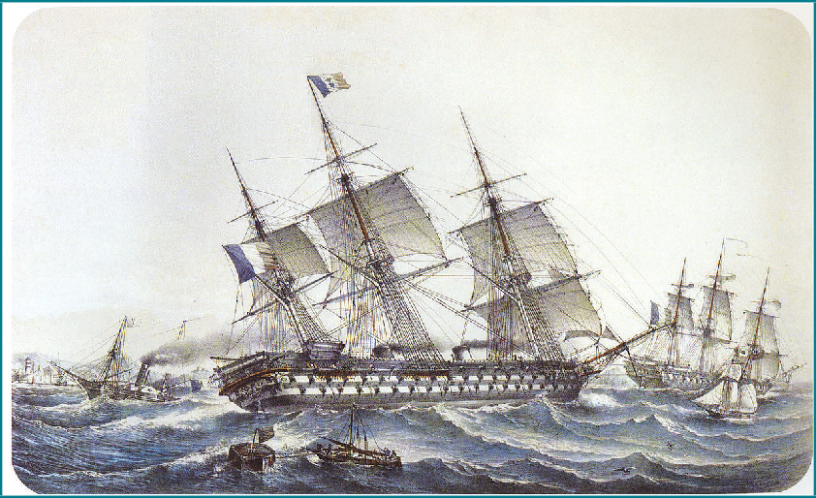ball, a kind of lead bullet that could be used in a rifled barrel, was adopted in the French army. Later, the Prussian Army developed the needle gun iii, a new type of breech-loading rifle that allowed soldiers to reload their weapons much quicker and without exposing themselves. By the mid-century, European armies started to develop and adopt rifled breech-loading artillery pieces. Early forms of machine guns saw their first use during the American Civil War. Metal cartridges that encased the propellant with the bullet emerged in the 1880s allowed even faster reloading and a higher rate of fire. Metal cartridges also enhanced the efficiency of machine guns. The same idea was later adopted in the design of artillery projectiles, leading to the emergence of “quick-firing” shells. This led to a substantial increase in the rate of fire for field artillery, especially after the emergence of the hydro- pneumatic recoil mechanism that allowed artillery pieces to fire continuously without repositioning.

Impact of the Industrial Revolution
The two centuries that followed the Military Revolution saw few breakthroughs in military technology until another wave of change occurred after the Revolutionary Wars and Napoleonic Wars (1792-1815), partly as the result of the Industrial Revolution. By the end of the century, the firepower of European armies was substantially augmented. Thus, the period was often termed “Firepower Revolution”. Smokeless powders, clip rifles, machine guns, as well as quick-firing guns all enhanced the firepower of European armies, while the emergence of steam engines, iron hulls, torpedoes, and ranger-finders brought fundamental changes in naval warfare. Also, non-military technologies such as railway, telegraph, radio, and the internal combustion engine changed the way people from around the world conceived and fought wars.

The firepower revolution of the 19th century started when European armies started to adopt a new generation of firearms and ammunition. In the 1830s, Minié

During this period, the mobility and versatility of the armed forces significantly increased. Steamship and railway substantially expanded the operation radius and logistic capability of European armies. In the early 19th century, sailing ships were still subjected mainly to weather conditions, ocean currents, and tides. Moreover, inshore sailing was still tricky and precarious. The use of steam allowed men to free themselves from being bounded by wind or animal power in navigation. Steamships sailed faster, and maritime traffic became more predictable because the steamships were less affected by the weather. These advantages were of great importance to the colonial empires that relied on maritime transport.
▲ Figure 5.3: Launched approximately in 1850, French battleship “The Napoléon” was the first steam battleship in history. (Louis Le Breton, Public domain, via Wikimedia Commons)

▲ Figure 5.4: French ironclad battleship Carnot, in service between 1897-1922. (© IWM Q 22259)

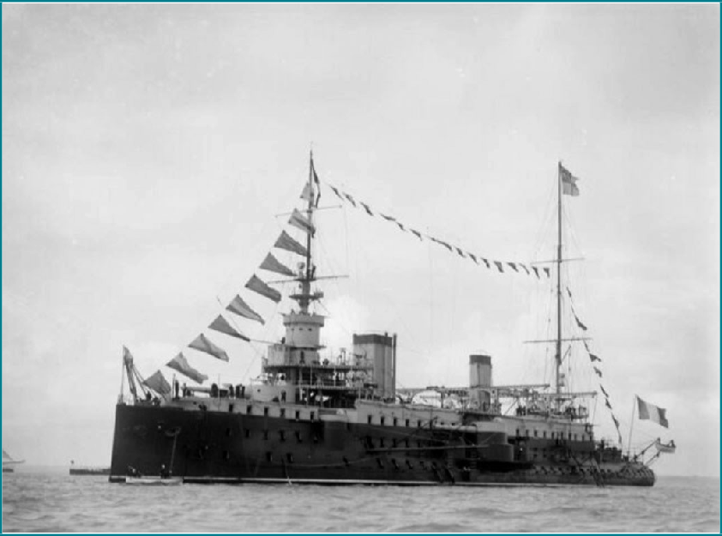

80 Chapter 5: War and Technological Innovations Chapter 5: War and Technological Innovations 81

On land, prior to the invention of the railway, armies and weapons were trans- ported by men or animals, and water transport was limited by the flow of rivers. The appearance of railways significantly enhanced the mobility of armies, although transport beyond railhead remained difficult until the emergence of the internal combustion engine. As long as an army fights along the rail line and have the line protected, in theory, it can receive a stable supply from the rear. In the Austro-Prus- sian War (1866) and Franco-Prussian War (1870-71), the Prussian Army, using railways, swiftly transported a considerable number of troops with their equipment to the frontline. The Prussian victory not only stunned the world but also demon- strated the strategic value of the railway.

The period also witnessed much change in communication technology during this period. Before the Industrial Age, armies and navies relied mainly on messengers, signal guns, bugles, or signal flags to communicate. Because of weather and circumstances, these means of communication often failed to work. Most important, none of the above could deliver complex messages quickly over a long distance. For example, it took months for London to deliver a message to its representatives in China during the period of the Opium War (1840-42). The invention of the telegraph in 1837, and the Morse Code that followed, made rapid long-distance communication possible. Decision-makers could learn about the situation at the front and react with unprecedented speed. The pace of events, as a result, accelerated. Telegraph was particularly crucial to the colonial powers that had possessions across the globe, enabling them to redeploy their troops quickly and more rationally. For example, in 1868, Britain, using the telegraph, redeployed her troops in India to Ethiopia at an unprecedented speed.

The advantage brought by the telegraph was mainly strategic, while the use of wireless radio brought both tactical and strategic advantages. Back in those days before the Industrial Revolution, once the troops were engaged, it would be almost impossible for the commanders to carry out complicated tactical moves since they had little means to communicate with his fighting subordinates. Wireless radio, however, allowed commanders to communicate with their subordinates at the front, to be informed about the situation, and redeploy their troops. As a result, commanders could exercise greater control of their units and, theoretically, the flow of the battle. However, radio was not widely used until after the First World War, because of the bulk of the early radio sets and the problem of reliability. The use of radio also brought significant changes to naval warfare, as it allowed headquarters to communicate with the scattered fleets all over the oceans so that strategic movements could be coordinated. Within a fleet, wireless radio also
permitted the commanders to communicate with their units as it provided a more reliable form of communication other than flag signals.
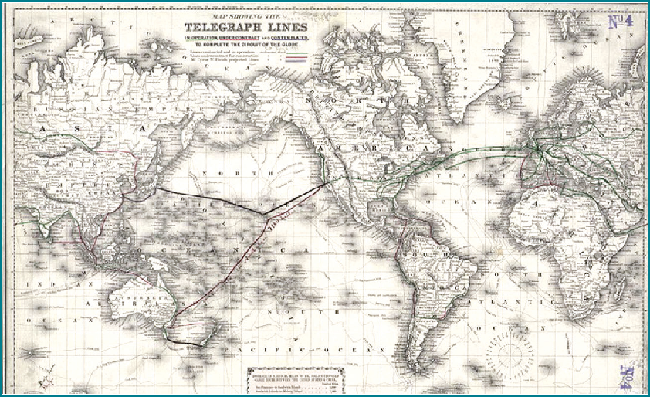
▲ Figure 5.5: World telegraph lines in 1871. (maps.bpl.org, CC BY 2.0, via Wikimedia Commons)

The aforementioned technological innovations, non-military as they were, nonetheless brought significant improvements in transport, logistics, and communication in the 19th-century battlefields. This reminds us of the close relationship between technological changes and warfare.

The Two World Wars: War of Technology

As the Industrial Revolution unfolded, the pace of change in military technology accelerated. Tactics and strategies that worked in the late 19th century were no longer applicable in the face of ever-changing weaponry, and the combat environment changed so quickly that even trained professionals failed to keep up. Some equipment became obsolete even before they were put into active service. The pace of change was further enhanced during the two world wars.

During the First World War, the Germans and Entente powers quickly found themselves trapped in protracted trench warfare, as the Western Front (the battlefield in Northern France and Belgium) turned into a deadlock. Eager to break the stalemate, all belligerents experimented with new weapons and tactics. Among all the inventions, chemical weapons, tanks, and aircrafts were once bestowed with

82 Chapter 5: War and Technological Innovations Chapter 5: War and Technological Innovations 83

high hopes. However, it was innovative combinations of old and new weapons and tactics, as well as the changing strategic outlook that broke the stalemate in 1918. During the war, a whole new air dimension emerged. Airplanes, originally used only for reconnaissance in 1914, became an essential weapon, and combat aircrafts with specialized roles such as fighter aircraftsiv and bombersv were put into action. Nevertheless, these were only some examples of the numerous inventions that were created in the war.
warfare is to destroy the enemy’s cities; while Billy Mitchell (1879-1936) from the USA proposed replacing the navy with an air force. At sea, the powers attempted to circumscribe armament race by treaties, leading to the 1922 Washington Treaty and 1930 Treaty of London; yet, they built aircraft carriers, “Treaty Cruisers”vi, and submarines. Furthermore, learning from their experiences in the Great War, navies revamped their tactical and operational doctrines.

▲ Figure 5.6: The British developed Mark I tank during the First World War and used it for the first time in 1916. (© IWM (Q 2488)

The end of the First World War did not bring about an end to rapid change in military technology. Instead, the experience of the war gave more incentive to the powers to invest in military technology, as technological superiority was seen as one of the reasons for the Entente victory, although political and economic factors were also seen as important. Technological innovations also led to tactical reforms during the interwar period. On land, armored warfare was intensively studied by almost all of the major powers, and they established new formations that consisted of tanks and other supporting vehicles. For the Germans, these units would prove to be instrumental in their early victories during the Second World War. Meanwhile, rich and poor countries all tried to build up an air force, while theorists proposed different ways to organize it and use it in wars. Giulio Douhet (1869-1930), an Italian, proposed strategic bombing aiming at destroying the adversary’s potential and will to fight; Arthur Harris (1892-1984), a British, believed that the crux of air
▲ Figure 5.7: IJN Kaga, one of the first aircraft carriers of Japan; photo taken in 1928. (Unknown author, Public domain, via Wikimedia Commons)

When war finally broke out again with Hitler’s invasion of Poland, the faith in military technology was buttressed in all nations. The belligerents poured capitals and recruited talents to develop more powerful weapons. Moreover, novel weapons that were unconceivable in the past appeared. Typical examples of these weapons include the German V-1 and V-2 rockets, as well as the atomic bomb, which brought an end to the war.

There were also other revolutionary inventions. Radar, a detection system that uses radio waves to determine the range and direction of objects from a distance, is one of such inventions. Radar expanded the detection range of armed forces, and significantly influenced aerial and naval tactics. During the Battle of Britain (1940), the British radar system, which was built in the mid-1930s, played a major role in fighting German bombers. Another worth-mentioning invention was the Enigma machine, an encryption machine used by the Germans. The Enigma

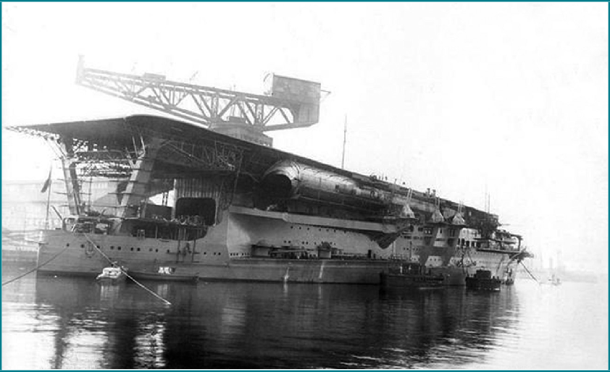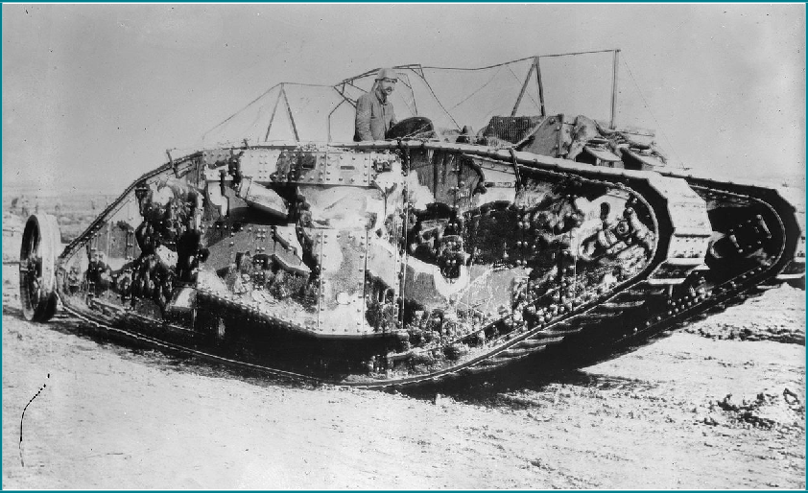
84 Chapter 5: War and Technological Innovations Chapter 5: War and Technological Innovations 85

machine allowed the Germans to communicate securely since the Allies would only be reading meaningless numbers and alphabets even if they had intercepted the messages. Germany’s advantage in communication remained until 1941 when Alan Turing (1912 – 1954)vii and his team cracked the Enigma machine in Bletchley Park, based on the contributions of the Polish intelligence service and academia.

▲ Figure 5.8: Before the invention of radar, armed forces used listening devices to detect incoming aircraft; the picture shows the Japanese Emperor inspecting listening devices and anti-aircraft guns during the 1930s. (Unknown author, Public domain, via Wikimedia Commons)

Lastly, technological innovation during the Second World War was not only about weapons and equipment but also in terms of production methods. In order to produce weapons cheaper, faster, and in large quantities, the Allies developed standardized weapons that were made of shared simpler parts. Typical examples include the Liberty Ships that became a symbol of American industrial might; the landing crafts that were vital to landing operations; and the jeep, which are still being used nowadays.

Summary
As the short discussion above illustrates, from the mid-19th century onwards, the rate of technological advancement was elevated to a level that was unimaginable in the past. A soldier from the Thirty Years’ War might well blend in quickly in a Napoleonic army, as the difference of techniques and tactics over the two centuries were not insurmountable, but a Napoleonic soldier would become a complete stranger in the trenches of the First World War. The Industrial Revolution could not solely explain such development; it was also the result of the change of mentality — how people perceived technological innovation. Before the Industrial Revolution, the importance of technological superiority was not fully recognized by any nation, nor was the value of military inventors adequately acknowledged. Moreover, there were no measures like patents that protected the rights and benefits of inventors. Technological breakthroughs, hence, were largely incidental.

However, through the Industrial Revolution, people saw continuity in technological developments. They realized that innovation could be achieved base on the knowledge and mechanisms fathomed from earlier inventions or discoveries. This perceptional evolution was termed as “the invention of invention”. Furthermore, the victories of Europeans over global civilizations, thanks to their superior weapon, were seen as proof of the importance of technological superiority. Thenceforth, all powers, striving for a leading position in military technology, stepped up in scientific research, gave rise to the armament race in the eve of the First World War. The enthusiasm for technological superiority did not end with the capitulation of Germany in 1919. On the contrary, the experience of the agonizing war reinforced the belief in technological innovation, which prompted them to invest more and more in military innovation. The belief in technological innovation culminated in World War Two when new weapons gushed out from laboratories and factories. Looking from retrospect, the fact that the atomic bomb forced Japan to surrender might well be the best verification for

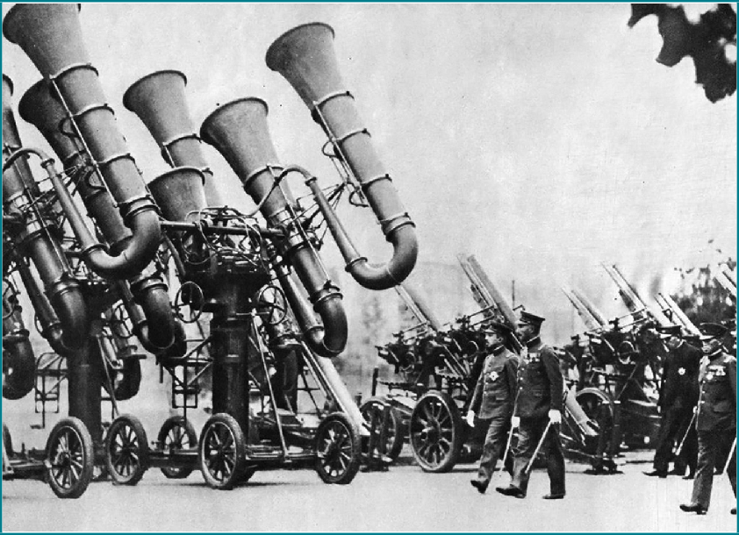
86 Chapter 5: War and Technological Innovations Chapter 5: War and Technological Innovations 87

Summary
the belief of the technological triumphalists.

Today, the level of military technology is a significant indicator of measuring a nation’s military strength. Nevertheless, as mentioned earlier, we should be aware of the danger of technological triumphalism; technological superiority alone cannot bring victory, and there is no such thing as a “decisive weapon” that could allow a country to win wars easily. Tactics, training, institution, as well as strategic contexts, all affect the efficacy of military technology. Had Maurice, Prince of Orange and Gustav Adolf not invented the linear tactics, musket would not have brought Military Revolution; had there been no well-trained pilots and the organization, the Royal Air Force would not have won the Battle of Britain; had the Americans not believed that the atomic bomb could be invented in time and terminate the war, the nuclear era may not have arrived. Thence, those who study history should evaluate the impact of technological innovation in proper contexts and clarify the relationship between warfare and technological innovation.

Suggested Readings:
Black, Jeremy. War and the World: Military Power and the Fate of Continents 1450-2000.
New Haven, Conn.: Yale University Press, 1998.

Black, Jeremy. War and Technology. Bloomington: Indiana University Press, 2013.

Headrick, Daniel R. The Tools of Empire: Technology and European Imperialism in the Nineteenth Century. New York: Oxford University Press, 1981.
Black, Jeremy. The Power of Knowledge: How Information and Technology Made the Modern World. New Haven : Yale University Press, 2013.
Martin Van Creveld, Technology and War: From 2000 B.C. to the Present. New York : Free Press ; London : Collier Macmillan, 1989.
歐陽泰（著）、陳榮彬（譯）。《火藥時代：為何中國衰弱而西方崛起？決定中西歷史的一千年》。台北：時報出版，2017。
歐陽泰（著）。《從丹藥到槍炮》。北京：中信出版社，2019。
歐陽泰（著）、陳信宏（譯）。《決戰熱蘭遮：中國首次擊敗西方的關鍵戰役》。台北：時報出版，2017。
李伯重。《火槍與帳簿：早期經濟全球化時代的中國與東亞世界》。台北：聯經，2019。

Meaning of terms:
- Michael Robert (1908-1996): An English historian specialising in the early modern period of the “military revolution” thesis.
- Trace Italienne: The fortification style emerged during the early modern period of gunpowder, designed to withstand siege artillery by eliminating “dead zones”.
- Needle gun: A firearm that emerged during the mid-19th century. It has a needle-like firing pin, which can pass through the paper cartridge case to strike a percussion cap at the bullet base.
- Fighter aircrafts: Fighter Aircrafts are military aircraft designed for air-to-air combat against other aircrafts.
- Bombers: Bombers are combat aircrafts designed to attack ground and naval targets by dropping bombs, missiles or torpedoes.
- Treaty Cruisers: The Washington Naval Treaty limited the tonnage and main gun size of the signatories’ navies. In response, the signatories attempted to build faster cruisers that are packed with the maximum amount of firepower.
- Alan Turing (1912-1954): An English mathematician and computer scientist, famous for cracking the Enigma machine of Nazi Germany, allowing the Allies to read intercepted coded messages of the German armed forces.

88 Chapter 5: War and Technological Innovations Chapter 5: War and Technological Innovations 89

